22.11.13 / hjv
Programme, version 2

WP 08: Fourth 2-days partner meeting, 2 – 3 Dec 2013 in Cardiff

Content
Practical information 1
Participants 2
Aims and key activities of the fourth meeting 3
Agenda of the partner meeting (version 1) 4
Annexes to the agenda of the partner meeting 5

Practical information
Time and meeting venue
From Monday 2 Dec, 9 am, to Tuesday 3 Dec, 4 pm
At Craft in the Bay, The Flourish, Lloyd George Avenue, Cardiff CF10 4QH (www.makersguildinwales.org.uk)

Travel information
- Fly into Cardiff Airport, get bus x91 to Cardiff bus station (40 minutes - times at http://www.buscms.com/CardiffBus/uploadedfiles/New_timetables_210713/X91_210713.pdf), and then BayCar bus or taxi to hotel/venue (10 minutes)
- Fly into Bristol Airport, get Greyhound bus to Cardiff bus station (1.5 hours - times at http://www.greyhounduk.com/), and then BayCar bus or taxi to hotel/venue (10 minutes)
- Fly into Bristol Airport, get Flyer bus to Bristol Temple Meads station (22 minutes - times at http://flyer.bristolairport.co.uk/), then train to Cardiff Central (30 minutes - train tickets at http://www.thetrainline.com), and then BayCar bus or taxi to hotel/venue (10 minutes)
- Fly into Heathrow, get Heathrow Express train to London Paddington (20 minutes), then train from Paddington to Cardiff Central (2 hours - train tickets at http://www.thetrainline.com - worth booking ahead to get cheaper prices), and then BayCar bus or taxi to hotel/venue (10 minutes)
Alternatively, the walk from Cardiff Central station to Craft in the Bay is 23 minutes: directions at http://tinyurl.com/oflvj6g
Hotels
The following prices were based on checking in on Sunday for two nights and travelling back on Tuesday after the meeting, but you may wish to stay longer.
Holiday Inn Express Cardiff Bay - 10 minutes walk to the venue - £129 for two nights (or £193 for three nights to the Wednesday).
Booking via hotel website: http://www.hiexpress.com/hotels/gb/en/cardiff/cdfba/hoteldetail or uk.hotels.com/ho184747/holiday-inn-express-cardiff-bay-cardiff-united-kingdom/
The St David's Hotel – fully booked!
Meals
Monday: Breakfast at the hotel. Lunch and coffee breaks at Craft in the Bay. Dinner at Maltsters Llandaff (minibus provided from venue and back to hotel).
Tuesday: Breakfast at the hotel. Lunch and coffee breaks at Craft in the Bay.

Cultural programme Monday evening
6pm – Llandaff guided history walk – “Llandaff - the ancient city within the modern city of Cardiff. Its narrow streets, pubs, and crumbling ruins create the atmosphere of a sleepy forgotten village, dominated by an ancient Cathedral, and one of Britain’s oldest Christian sites, near the banks of the river Taff. However, behind the peace and quiet of Llandaff lies a turbulent past of war, plunder, disaster, and tragedy. Little wonder then that this tiny hamlet is teeming with stories, legends, and hauntings, ancient and modern.”
Map of Meeting area
https://maps.google.co.uk/maps?ll=51.46898,-3.166981&spn=0.015666,0.042272&t=m&z=15

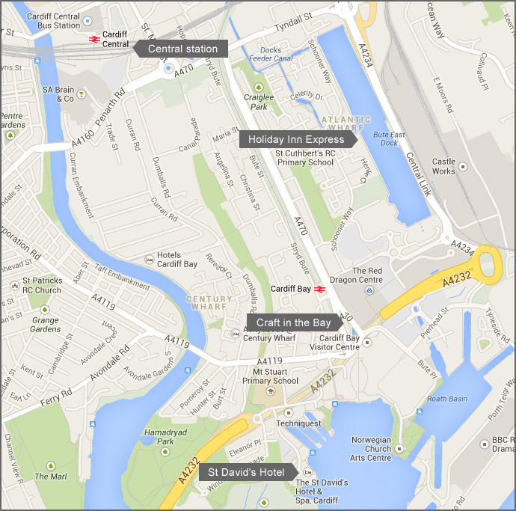

Participants
For the partner meeting/ project members - mobile numbers
Robin Simpson, UK (+44) 783 469 3819
Daniel Carpenter, UK (+44) 773 969 0762
Gillian Harrison, UK (+44) 7545 766 940
Maxine Webster, UK (+44) 7880 742 584
Jan van den Eijnden, NL (+31) 6 53 64 88 98
Chantal de Bonth-Vromans, NL (+31) 6 5159 3099
Sven Ögren, SE (+46) 70 29 46 881
Gunnel Hillerström Bengtsson, SE (+46) 73 15 67 555
Marjeta Turk, SI (+386) 31 817 358
Urška Bittner Pipan, SI (+386) ??
Bente von Schindel, DK (+45) 29 64 70 40
Hans Jørgen Vodsgaard, DK (+45) 51 300 320

Aims and key activities of the fourth meeting
Aim and objectives
The overall aim is to bridge the third and fourth project phase.
The objectives are
- to evaluate the pilot tests, and
- to plan the valorisation and the European seminar.
Key activities of the partner meeting
Before:
8.1 Plan the agenda and practical issues
8.2 Present notes on pilot tests and used methods and outcome
8.3 Fill-out evaluation questionnaire of third phase (process as well as impact evaluation)
During the meeting:
8.4 Present and conclude on the outcome of the pilot tests
8.5 Prepare a draft programme of the European Seminar
8.6 Prepare the valorisation plan for the last phase
8.7 Cultural excursions and meetings with stakeholders.
8,8a Evaluation of the third phase, summaries of questionnaires and oral evaluation
8.8 Evaluate the fourth meeting – oral and with a succeeding questionnaire
Follow-up:
8.9 Minutes and valorisation plan incl. draft programme of seminar in Holland
8.10 Upload notes on pilot test on web-sites
8.10a Upload pictures and reportages from the fourth meeting on the website
8.11 Disseminate news-mails-4.

Agenda of the partner meeting (version 2)

Monday, 2 Dec, 9 – 17
1. Formalities
a) Practical information by the host
b) Appoint a moderator and a reporter
c) Approval of the minutes of third meeting and the agenda of the fourth meeting
d) Sign Attendance List
2. Since last time: Info on matters not included in the items below
a) Review of our video conference on 10 October at 2pm
b) Other issues
3. Present and conclude on the outcome of the pilot tests (WP 7)
a) Short presentations of work and outcome by each partner
b) Summary of conclusions on WP 7, all partners
1.30 pm - Presentation by Emma Robinson, Arts and Creativity Development Officer at Age Cymru (Age Wales). Emma is the organiser of the Gwanwyn Festival, a month-long national festival held across Wales in May celebrating creativity in older age.
4. Present and conclude on the outcome of the current valorisation activities (WP 12)
a) Short presentations of the valorisation activities until now by each partner
b) The project website
c) Summary of conclusions on WP 12, all partners
5. Evaluation of project progress (until now), summaries of questionnaires and oral evaluation
a) Summaries of questionnaires, process and impact evaluation
b) Evaluation round, process evaluation, by all partners
c) Evaluation round, impact evaluation, by all partners
d) Summary of conclusions
Cultural programme, Monday evening
Taxis to Llandaff at 5.30pm for history walk and dinner at the Maltsters

Tuesday, 3 Dec, 9 – 16
6. Prepare the programme of the European Seminar in Utrecht, 6 – 8 April 2014 (WP 9)
a) Presentation of draft programme, by LKCA
b) Discussions and decisions on programme, participants, financial and practical issues
c) Summary of the conclusions, tasks and deadlines
d) Schedule fifth meeting in Utrecht, 9 April 2014
7. Plan the final valorisation activities of fourth phase, January – May 2014
a) Plan the dissemination activities (WP 10)
b) Plan the exploitation activities (WP 11)
c) Summary of the conclusions, tasks and deadlines
8. Evaluation of the fourth meeting
a) Oral evaluation round of the fourth partner meeting
b) Fill-out the meeting evaluation questionnaire (during or soon after the meeting)
9. A.O.B. (any other business)

Annexes to the agenda of the partner meeting
Item 1: Formalities
c) Minutes of the third meeting (send 07.06.2013 by Daniel)
Agenda of the third partner meeting
d) Template, meeting attendance List (distributed and signed at the meeting)
Item 2: Since last time
None
Item 3: Present and conclude on the outcome of the pilot tests (WP 7)
a) Short presentations of work and outcome by each partner (deadline 28 Nov)
Memo from P1: IF
Memo from P2: KSD
Memo from P3: LKCA
Memo from P4: VA
Memo from P5: LF
Memo from P6: JSKD
Item 4 - 5: Evaluation of concluded WP 7 and related valorisation
a) Filled-out evaluation questionnaire on valorisation activities until now (deadline 28 Nov)
by P1: IF
by P2: KSD
by P3: LKCA
by P4: VA
by P5: LF
by P6: JSKD
b) see http://www.theloveofit.org/art-age/
Item 6: Prepare the programme of the European Seminar in Utrecht, 6 – 8 April 2014 (WP 9)
a) Written outline of programme, by LKCA
Item 7: Plan the final valorisation activities of fourth phase
None
Item 8: Evaluation of the fourth meeting
b) Template, evaluation questionnaire for the fourth partner meeting, version 1

Item 9: A.O.B. (any other business)
None

