Questionnaire

for

assessment of learning profile

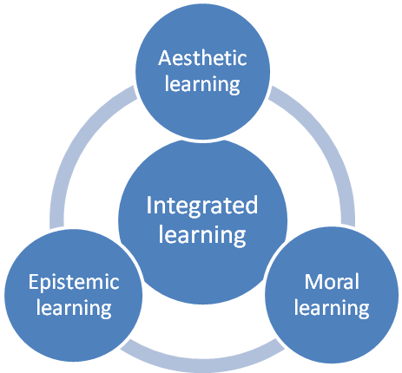

© Interfolk and Cultural Council in Denmark, October 2013, first edition

Introduction to the questionnaire

Learning has in recent years become an important concept in pedagogy, education and NGO activities. The formal learning takes place in formal education from primary school to university, the non-formal learning in liberal adult education, and the informal learning in voluntary civil society associations, including voluntary arts and culture activities.
A major problem with the current educational agenda is the very one-sided focus on the learning of useful applicable knowledge as employees in the business community (primarily epistemic learning), while other types of learning such as the moral and aesthetic learning, particularly of value to us as citizens and fellow human beings have a low priority.
This questionnaire, contrarily to the more instrumental learning agenda, has methodically assigned a concurrent importance to the moral and aesthetic learning. The questionnaire includes four learning dimensions: The epistemic, moral and aesthetic learning and their degree of integration and synergy.
The applied threefold determination of learning refers methodically to the classic antique division of our personality in reason, will and feelings, which respectively seeks the true, the good and the beautiful. This tripartite division is to a great extent also used in modern philosophy and pedagogy, for example by Kant and Habermas that also divides the mental faculties in
- An epistemic dimension, especially using reason to understand, describe and assess facts and laws (what there is) by using common sense or by using science and logic.
- A moral dimension, especially using the will to justify norms and values ​​(what ought to be), and to practice these norms.
- An aesthetic dimension, especially using senses and feelings to enjoy and judge the beauty of nature and culture and to discover and create beauty and joy in life.
- An underlying dimension, where we as integrated persons join these different abilities so that they can work together in synergetic unity.
In the questionnaire, each dimension is divided into two aspects, foundation and action, each with six keywords (and derived key questions). This gives a total of 48 questions (4 dimensions x 2 aspects x 6 questions), where you must assess their importance on a five-point scale ranging from “very low degree” to “very high degree”. The four dimensions and their 48 key words are the following:
Epistemic dimension
Foundation | Curiosity, self-control, investigative, broad orientation, interdisciplinary, and personal attitudes.
Acting | Rational, analytical, sense of perspective, critical thinking, purposeful, and independent.
Moral dimension
Foundation | Self-confidence, courage of life, empathy, compassion, reciprocity, and autonomous.
Acting | Respectful, Golden Rule, solidarity, responsible, dialogue-oriented, and democratic.
Aesthetic dimension
Foundation | Self-sense, joy of life, self-forgetfulness, sensitivity, intuition, and authentic.
Acting | Marvel ability, spontaneity, sensuous, poetic, imaginative, and creative.
Dimension of integration
Foundation | Self-esteem (unity of self-sense and self-confidence), fullness of life (joy and courage reinforce each other), happiness, rhythmic (between control and spontaneity), integration (of reason and feelings), and autonomy.
Acting | Involvement (of all abilities), interaction (of understanding and imagination), balance (of reflection and intuition), energetic, harmonious, and free.

In addition to the 48 closed questions there are 4 extra closed questions for the four dimensions, where you must try to assess the importance of your activity in voluntary arts for the development of your learning profile, and furthermore there is an open question for each dimension, where you can provide examples of the possible benefits your voluntary arts activities have had for the development of your learning profile.
Enjoy yourself - start on the series of questions.

Background information
This information can help us to valuate, if factors such as type of voluntary activities, role in organization, gender, age, education and employment imply clear differences in the answers on the subsequent questions about learning qualities.

A | Gender | Male | Female
A | I am .. (tick one box)

B | Age | 15 – 17 years | 18 – 29  years | 30 – 39 years | 40 – 49 years | 50 – 59  years | 60 – 69 years | 70 – 99  years
B | My age is .. (tick one box)

C | Educational background | Primary School  (7 – 15 year) | Gymnasium  (16 – 19 year) | Technical vocational education  (16 – 19 year) | Short higher education  (1-2 year) | Middle higher education  (3-4) | Longer Higher  education  (4-7 år) | Other
C | My highest education is .  (tick one box)

D | Occupation | Private  sector | Public  sector | Civil society  (Associations  or institutions) | Full time  student | Out of work  (retirement etc) | Other
D | My occupation is ..  (Tick one box)

E | Primary civil society activity | Liberal adult education | Social and humanitarian NGO-activity | Environment and Nature NGO-activity | Solidarity and Human Rights NGO-activity | Voluntary Arts  activities | Voluntary Culture  activities | Other  Ngo  activities
E | My primary NGO-activity is ..  (tick one box)

F | Your main activity in the primary civil society organization  (describe briefly)

I. Epistemic learning  Key words are for  - Foundation: Curiosity, self-control, investigative, broad orientation, interdisciplinary, and personal attitudes.  - Acting: Rational, analytical, sense of perspective, critical thinking, purposeful, and independent. | 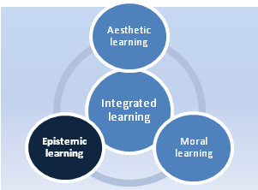

Assessment of your epistemic learning  Here you must assess your degree of epistemic learning.  Indicate to what extent the statements apply to you. (Tick one box for each statement). | Very low degree | Low degree | Some degree | High degree | Very high degree
Foundation
I like the process of learning
I don’t give up, when I want to learn something new, even though it is difficult
I'm good at to acquire extensive knowledge on selected topics
I have a general knowledge of society, culture and nature.
I'm good to combine my knowledge to get an overview of a difficult subject
I can have a personal opinion to my acquired knowledge
Acting
I can act judiciously even in stressful emotional situations
l I'm good at analyzing a situation and identify the key issues
I am good in getting an overview and seeing connections between different fields of knowledge
I am able to (self-) critically assess the value of my knowledge and opinions
I can focus myself to solve difficult tasks
I can take an independent position on major issues

Learning benefits of the activities in voluntary arts
Indicate to what extent your activities in voluntary arts have developed your epistemic learning?
Give optionally one or more examples of how your participation in voluntary arts has helped to develop your epistemic learning profile!

II. Moral learning  Key words are for  - Foundation: Self-confidence, courage of life, empathy, compassion, reciprocity, and autonomous.  - Acting: Respectful, Golden Rule, solidarity, responsible, dialogue-oriented, and democratic. | 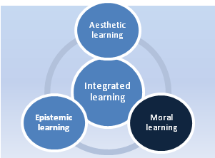

Assessment of your moral learning  Here you must assess your degree of moral learning.  Indicate to what extent the statements apply to you. (Tick one box for each statement). | Very low degree | Low degree | Some degree | High degree | Very high degree
Foundation
I am confident that I can create change and make a difference
I have courage in life
I am emphatic to the conditions of other people
I have compassion for other people's misery
I acknowledge that others may have different opinions than mine.
I trust on my own judgement
Acting
I respect other people as the unique persons, they are
I treat others as I want them to treat me
I want us to stand in solidarity with others, even though it may cost me something.
I take responsibility to resolve common challenges
I appreciate an equal community characterised of trust and dialogue
I believe that everyone should have a word to say in the communities, they are part of.

Learning benefits of the activities in voluntary arts
Indicate to what extent your activities in voluntary arts have developed your moral learning?

Give optionally one or more examples of how your participation in voluntary arts has helped to develop your moral learning profile!

III. Aesthetic learning  Key words are for  - Foundation: Self-esteem, joy of life, self-forgetfulness, sensitivity, intuition, and  authentic.  - Acting: Marvel ability, spontaneity, sensuousness, poetic, imaginative, and  creative. | 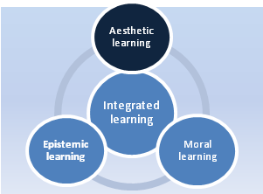

Assessment of your aesthetic learning  Here you must assess your degree of aesthetic learning.  Indicate to what extent the statements apply to you. (Tick one box for each statement). | Very low degree | Low degree | Some degree | High degree | Very high degree
Foundation
I feel myself at home in the world
I am happy for life
Often I experience to be so fully engaged in something that I forget myself.
I have a developed sense of moods and emotional meanings
I can use my intuition to assess situations
I do not hide who I am
Acting
A starry night, I can be gripped by a profound astonishment of the world's greatness
I find it easy to act spontaneously and unconstrained ..
I can communicate experiences by means of body language and other sensual expression
I can express myself with poetic imagery and narratives
I can use my imagination, when I seek new opportunities
I like to experiment and test alternative solutions

Learning benefits of the activities in voluntary arts
Indicate to what extent your activities in voluntary arts have developed your aesthetic learning?

Give optionally one or more examples of how your participation in voluntary arts has helped to develop your aesthetic learning profile!

IV. Integrated learning  Key words are for  - Foundation: Self-esteem (unity of self-sense and self-confidence), fullness of life (where joy and courage reinforce each other), open for happiness, rhythmic (between control and spontaneity), integration (of reason and feelings), and autonomy.  - Acting: Involvement (of all abilities), interaction (of understanding and imagination), balance (of reflection and intuition), energetic, harmonious, and free. . | 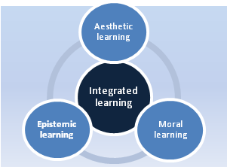

Assessment of your integrated learning  Here you must assess your degree of integrated learning.  Indicate to what extent the statements apply to you. (Tick one box for each statement). | Very low degree | Low degree | Some degree | High degree | Very high degree
Foundation
I have a good self-esteem - for example, I see myself as a valuable person even when tasks fail
I see my life as meaningful and valuable
I feel sometimes a great sense of happiness
In various contexts I can alternate between self-control and spontaneity
I can both use my reason and my feelings, when I judge a situation
I see myself as a free human being with a diverse and independent judgment
Acting
I can involve myself fully in situations that really interests me
I often solve a new task using both my reason and my imagination.
In various contexts I act on the basis of both reflection and intuition
I can be vigorous when needed.
I see myself as a whole and harmonious person
I uphold my freedom to find my own path in life.

Learning benefits of the activities in voluntary arts
Indicate to what extent your activities in voluntary arts have developed your integrated learning?

Give optionally one or more examples of how your participation in voluntary arts has helped to develop your integrated learning profile!

Possible comments
If you have comments or critics of the questionnaire, or want to explain your answers, you are welcome to write them below
General comments:
Comments to the epistemic learning dimension:
Comments to the moral learning dimension:
Comments to the aesthetic learning dimension:
Comments to the integrated learning dimension:

"A well-founded knowledge of what is deemed to be factually true."
"Treat others as you want to be treated by them"

