27.05.13 / hjv
Programme, version 2

WP 06: Third partner meeting and seminar,
4th – 5th of June 2013 in Copenhagen

Content
Practical information 1
Participants 2
Aims and key activities of the third meeting and seminar 3
Programme for the seminar (version 1) 4
Annexes to the seminar 4
Agenda of the partner meeting (version 1) 5
Annexes to the agenda of the partner meeting 6

Practical information
Time and curse venue
From Tuesday, 4 June, 10 am - to Wednesday, 5 June, 4 pm
At ”Grundtvigstuen”, Vartov, Farvergade 27, DK-1463 Copenhagen K
NB: just 100 meter from the City Hall at the center of the city
See www.grundtvig.dk

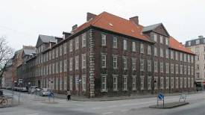 | 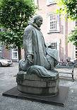 | 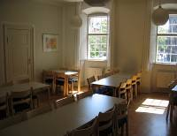
Vartov | Statue of Grundtvig | Grundtvig’s Room
Travel information
From Copenhagen Airport to the centre of the city. Take the metro from the airport to Nørreport Station. Vartov is just round the corner from the Town hall Square (Rådhuspladsen).
See http://www.krak.dk/f/vartov:68124495/1463-k%C3%B8benhavn-k
Hotels
Not so cheap:
Hotel Danmark http://wwwbrochner-hotels.dk (Very close!)
Best-western-Hotel-Hebron-Copenhagen- http://www.bestwestern.dk/da/hotels/best-western-hotel-hebron-copenhagen-description (10 min.)
Copenhagen Star Hotel http://www.copenhagenstar.dk (10 min.)
Cheap
Hotel CABINN Metro http://www.hotel.dk/hotel-cabinnmetro.html (20 – 25 min. / bus – 10 min.)
Danhostel cph Downtown: http://da.hotels.com/ho279295/danhostel-copenhagen-downtown-k-benhavn-danmark (Very close!)
Danhostel cph City http://www.danhostel.dk/hostel/danhostel-copenhagen-city (10 min.)
Meals
Tuesday: (Breakfast at the hotel), Lunch at Vartov. Dinner in Town. Coffee breaks at Vartov.
Wednesday: Breakfast at the hotel. Lunch at Vartov. Coffee breaks at Vartov.
Cultural programme Tuesday evening
Visit and guided tour at the Royal Opera House – see http://kglteater.dk/
Dinner in New Harbour district – see http://en.wikipedia.org/wiki/Nyhavn

Map of Copenhagen centre
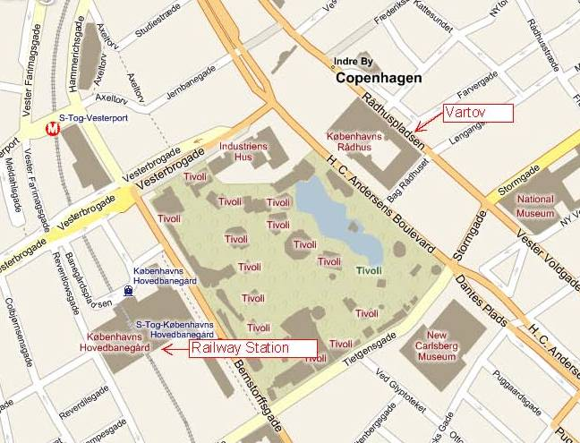

Participants
For the partner meeting/ project members - mobile numbers
Gillian Harrison, UK (+44) (0)7545 766 940
Daniel Carpenter, UK (+44) 773 969 0762
Jan van den Eijnden, NL (+31) 6 53 64 88 98
Chantal de Bonth-Vromans, NL (+31) 6 5159 3099
Michael Deubler, SE (+46) 073-047 28 33
Sven Ögren, SE (+46) ??
Marjeta Turk, SI (+386) (1) 24 10 510
Urška Bittner Pipan, SI (+386) ??
Bente von Schindel, DK (+45) 29 64 70 40
Hans Jørgen Vodsgaard, DK (+45) 51 300 320
Aims and key activities of the third meeting and seminar

Aim and objectives
The overall aim is to qualify the succeeding pilot surveys
The objectives are
- To present and clarify useful methods for learning documentation & validation, and
- To plan the succeeding pilot surveys (test of methods) in the autumn 2013

Key activities of the partner meeting
Before:
6.1 Planning the agenda and practical issues (IF and KSD)
6.2 Prepare presentation of project dissemination activities until now (all partners)
6.2 Prepare presentations of the chosen methods for documentation & validation (all partners)
6.4 fill-out the evaluation questionnaire of the second project phase (all partners)
During the meeting:
6.5 Present dissemination activities until now (transversal WP 12)
6.6 Present and discuss the chosen methods for documentation & validation (completed in WP 5);
6.7 Adopt task plan for the third phase – pilot documentation tests (WP 7) and fourth meeting (WP 8);
6.8 Cultural excursions and meetings with stakeholders.
6.9 Oral evaluation of second phase (WP 4-6)
6.10 Evaluate the third meeting and the seminar – oral and with a questionnaire (WP 6)
6.11 Discuss the demands for the interim report by all partners to the national agencies
Follow-up:
6.12 Minutes and detailed task plan of third phase,
6.13 Disseminate notes on chosen methods on website and news-mail-3

Key activities of the seminar
6a Plan the seminar programme (KSD)
6b Presentations of guidelines for documentation and validation
6c Discussions and exchange of experiences

Agenda of the partner meeting (version 2)
Tuesday, 4 June, 10 – 12
1. Formalities
a) Practical information
b) Appoint a moderator and a reporter
c) Approval of the minutes of second meeting and the agenda of the third meeting
d) Sign Attendance List
2. Presentation round and welcome to new participants
a) The partner e-mail list – which persons shall be on the list
3. Since last time: Info on matters not included in the items below
a) Information about JSKD as “new” project partner
b) Information from the bilateral meeting in Åsa, 27 February 2013
d) Interim reports to the National Agencies, 1st of June, 2013
d) Other issues
4. Recapitulation of WP 3 - the need analysis/presentation of baseline
a) Short presentation, by Marjeta Turk, JSKD and Sven Ögren, LF
c) Summary of conclusions on WP 3, all partners
Lunch, 12 – 12.45
SEMINAR, 13 – 17.00 – see separate Seminar Programme
Cultural visit, activity
17.15 Taxi to the Royal Opera
17.30 Guided tour at the Opera - – see http://kglteater.dk/
19.30 Dinner in New Harbour district (Nyhavn) - see http://en.wikipedia.org/wiki/Nyhavn
Wednesday, 5 June, 9 – 16
5. Chosen documentation methods of art-based learning outcome and active ageing (WP 5)
a) Presentation of chosen methods – process and results, all partners
b) Summary of conclusions
6. Issues regarding valorisation (transverse WP 12)
a) Reports on own valorisation activities until now, all partners
b) The project website and final logo
c) Summary of conclusions
7. Plan the third phase, autumn 2013
a) Plan the pilot tests of documentation method (WP 7)
b) Plan the fourth partner meeting (WP 8) – maybe from Cardiff to Ljubljana?
c) Plan the valorisation in the third phase
d) Summary of the conclusions, tasks and deadlines
8. Other issues - use of mobilities, interim reports, frame for the seminar in Holland, etc.
a) Frame of concluding seminar in Holland, April 2014, date and number of participants (WP 10)
b) Use of mobilities – can all count to 12
d) Other financial and management issues
9. Evaluation of the previous work
a) Summary of evaluation questionnaires from the second phase (WP 4 – 6)
b) Oral evaluation round on the second phase (WP 4 - 6)
c) Oral evaluation round of the third partner meeting (WP 6a)
d) Oral evaluation of the seminar (WP 6b)
d) Fill-out the meeting evaluation questionnaire (during or soon after the meeting)
10. A.O.B. (any other business)

Annexes to the agenda of the partner meeting
Item 1: Formalities
c) Minutes of the second meeting (send 20.02.2013)
Agenda of the third partner meeting, version 2 (later)
d) Template, meeting attendance List, version 3, 02-05-13 (distributed and signed at the meeting)
Item 3: Since last time
a) Minutes from the bilateral SE-DK meeting 27.2.2013 in Åsa (send 01.03.2013)
Item 4: Recapitulation of WP 3 - the need analysis/presentation of baseline
a) JSKDs baseline (latest 20.05.2013)
b) LFs baseline (send 31.03.2013)
Item 5: Chosen documentation methods of art-based learning outcome and active ageing (WP 5)
a) Short memos (1 – 2 pages) from all partners on WP 5 (deadline 20.05.2013)
Memo from P1: IF (send 13.05.2013)
Memo from P2: KSD (send 24.05.2013)
Memo from P3: LKCA
Memo from P4: VA
Memo from P5: LF
Memo from P6: JSKD
Item 6: Issues regarding valorisation
a) Template, partner monitoring report, WP 12 (and WP 5), version 1 (send 03.05.2013)
Filled-out by all partners (deadline 20.05.2013) NB: The same as used in item 9a below.
b) The project website – see http://www.theloveofit.org/art-age/
c) The final logo – presented by VA (deadline 20.05.2013)
Item 8: Other issues
b) Budget of mobilities – Revised April 2013
Item 9: Evaluation of the previous work
a) Filled-out template, partner monitoring report, WP 5 (and WP 12), version 1 (send 03.05.2013)
by all partners (deadline 20.05.2013). NB: The same as used in item 6a above.
Report from P1: IF (send 13.05.2013)
Report from P2: KSD (send 24.05.2013)
Report from P3: LKCA
Report from P4: VA
Report from P5: LF
Report from P6: JSKD
d) Template, evaluation questionnaire for the third partner meeting, version 1 (send 03.05.2013).
Filled-out by all partners (deadline 12.06.2013)
Meeting evaluation from P1: IF
Meeting evaluation from P2: KSD
Meeting evaluation from P3: LKCA
Meeting evaluation from P4: VA
Meeting evaluation from P5: LF
Meeting evaluation from P6: JSKD

