**Local pilot course in culture/art and harvest festival in rural areas, Hungary**

**Time: June 2014**

**Place: Balaton upland region**

**Duration: three days**

**Selection of the places will be from the villages that attended the introductory meeting on the 11th of December :**Balatoncsicsó, Tagyon, Zánka, Örvényes, Balatonszepezd, Mindszentkálla, Szentbékálla, Balatonakali, Aszófő

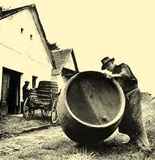

**Common issues in the pilot course**

* Introduction to the Culture Guide Project
* Presentation on the history of the wine growing culture in the region – and its national and international context
* Connection of culture, art and winegrowing - tradition and modernity
* Marginalised social groups and culture
* Video presentation of recent harvest festivals from the region – analyses, evaluation in order to put together “good practice” elements
* Documentation and dissemination ( photo, video)
* Use of media and social media for the event

Separated parts of the course

1. **For the group of organizers, facilitators, amateur art group leaders, experts (method: lectures, interactive workshops, targeted and moderated sharing of experiences)**

**Main topics**: overview and discussion of the elements of the relationship of harvest festivals with culture and art

* preparatory work of and organising such events and the main attractions of a vintage procession
* collection of songs, singing together, dancing, recitations, poems, speeches
* decoration of the farm-wagons, decoration of streets, clothing of people, traditional costumes
* presentations, wine stories in front of the public
* stations of wine procession, programmes, activation of people gathered together
* traditional cooking at harvest festivals, hospitality, offering a selection of wines for people during the festival day
* 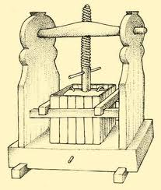

1. **Active volunteers - topics**

* how to involve more people
* how to become ambassadors, and to attract marginalised groups
* sharing of experiences of earlier wine festivals from the point of view of art, culture and marginalised groups
* listing and structuring personal contributions of volunteers and artistic aspects
* how people can teach others (recruiting enough number of volunteers for the success of the event)

**Output:**

* prepared facilitators, amateur artistic groups, active volunteers
* model scenario for common use
* practical guide for local organisers, artists and volunteers
* plan of documentation for dissemination

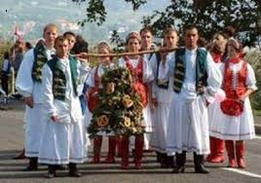

**Prepared by HFHSS**