27.05.13 / hjv
Programme, version 4

Seminar on art-based learning and active ageing
4 June 2013, 13.00 – 17.05
in Grundtvigstuen”, Vartov, Copenhagen

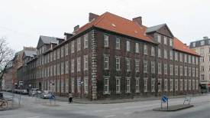 | 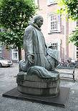 | 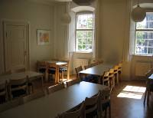
Vartov | Statue of Grundtvig | Grundtvig’s Room

Participants
From the Grundtvig Learning Partnership
UK: Gillian Harrison, VA; Daniel Carpenter, VA; Dominic Campbell (Speaker)
NL: Jan van den Eijnden, LKCA; Claudia Marinelli, LKCA; Chantal de Bonth-Vromans, LKCA (speaker)
SE: Sven Ögren and Michael Deubler, Löftadalens folkhögskola
SI: Marjeta Turk, JSKD; Urška Bittner Pipan, JSKD
DK: Bente von Schindel, KSD (moderator); Hans Jørgen Vodsgaard, IF (speaker)
Danish guests / experts
Invited by IF: Niels Bendix Knudsen, principal of Rite Folk High School in Latvia; Lis Hasel Nielsen, vice principal of Rite Folk High School in Latvia; Mogens Hemmingsen, culture consultant Copenhagen Municipality; Susan Fazakarley, secretary general of the Amateur Art and Culture Association (AKKS);
Invited by KSD: Bente Hanke, Music Council, Ballerup; Carsten Egø Nielsen, Cultural Council, Slagelse; Rikke Rottensten, Danish Theater Association; Annemarie Holm, The Danish Adult Education Association.

Programme for the seminar (version 4)
Tuesday, 4 June, kl. 13.00 – 17.30 at Grundtvigstuen”, Vartov, Copenhagen
13.00 Welcome and programme presentation
Presentation of participants
By Bente von Schindel
13.15 First presentation:
Experiences with arts-based learning and older people incl. possible validation methods
By Dominic Campbell (UK), independent philanthropy arts entrepreneur and Director of the Bealtaine Festival, an annual month-long, festival celebrating creativity in older age.
13.55 Questions and discussions
14.15 Coffee break
14.30 Second presentation:
The current situation in The Netherlands concerning elderly people and arts participation
By Chantal de Bonth and Claudia Marinelli, adviser in LKCA: Landelijk Kennisinstituut Cultuureducatie & Amateurkunst
15.10 Questions to and discussions
15.30 Coffee break
15.45 Third presentation:
Outline of a aesthetical learning theory with reference to Kants Critical Philosophy
By Hans Jørgen Vodsgaard (DK), Mag. Art., Head of Interfolk
16.25 Questions to and discussions
16.40 Summary of the presentations and discussions
By Bente von Schindel and the participants
17.00 End of seminar
.

Annexes to the seminar
Possible power points from the presentations

