BvS and HJV, 15.02.2017

**Second 2-day partner meeting in Copenhagen, 19 – 20 April 2017**

***Programme and Agenda, version 1***

*Content*

Time and place 1

Practical information 2

Mobile numbers of the participants 3

Aims and key activities of the first meeting 3

Agenda of the meeting (version 1 – 15.02.2017) 4

## Time and place

*All partners can get meeting unit support for max two participants.*

**Place: At Vartov, Farvergade 27 D, 2nd, DK-1463 Copenhagen K**

NB: just 100 meter from the City Hall at the center of the city

See [www.grundtvig.dk](http://www.grundtvig.dk) and <http://map.krak.dk/?index=yp&id=68124495&query>=

**Time: Wednesday, 19 April, 11:00 – Thursday, 20 April, 16:00**

Time schedule for the meeting

Wednesday: 11:00 – 17:00 Agenda issues including lunch and coffee breaks

17:15 – 18:30 City walk

18:30 – 20:00 Common Dinner

Thursday: 09:00 – 12:30 Agenda issues including coffee break

12:30 – 13:15 Lunch

13:30 – 15:30 Individual counselling with Helene Clark on ToC methodology

15.30 – 15:45 Farewell

Information about the meeting place

|  |  |  |
| --- | --- | --- |
|  |  |  |
| Vartov | Statue of Grundtvig | City Hall tower seen from Vartov’s courtyard |

Vartov is an historic and beautiful building with Copenhagen City Hall as its closest neighbour.

Vartov is known to have had the famous Danish poet, priest and adult educator N.F.S. Grundtvig as pastor in 33 years from 1839 to 1872 at the Vartov church which is part of the building complex.

In 1947 the Danish Grundtvig Society took over Vartov. The building underwent an extensive restoration and was particularly adapted for their new purpose, which was a continuation of the Grundtvigian youth and educational work.

Today the Grundtvig library and the Grundtvig Academy and the Søren Kierkegaard Research Centre as well as many educational and cultural umbrella associations have addresses here.

## Practical information

**Refunding of costs**

The gross unit support per person of 760 euro for P6, ML and 575 euro for P1, VAN; P4, MNT and P5, FAIE. This amount will be refunded (minus each partner’s share of the host cost for common meals, rent of venue, etc.) independently of how many nights and days the meeting are and the cost of hotels and meals are.

Therefore, we plan for a short meeting and low-cost meals and cultural features, so you in fact can get your meetings costs covered. You are of cause welcome to stay more days, but you or your organisation must pay the extra cost.

The needed documentation for your participation is a signed attendance list and a copy of your boarding cards and hotel bill. There is no rule against combing a partner meeting with a prolonged stay as tourist.

**Hotel**

For accommodation, we recommend

City Hotel Nebo (<http://city-hotel-nebo.8hotels.info> ).

The hotel is only minutes walk from the Main Railway Station and Tivoli Gardens, and 5 min walk from the City Hall and Vartov.

**Travel information**

Use S-train from Copenhagen Airport (Terminal 3, platform 2,) to the Main Railway Station (København H). It takes approx. 20 min. The walk from the Station to City Hotel Nebo is only 2 min.

Tickets for the Metro and train (3 zone ticket) are available at the Metro station and at the DSB ticket sales counter in Terminal 3. Please note that the ticket machines do not accept notes, only coins and cards such as VISA, etc.

**Meals**

Wednesday, 19 April :

Lunch at Vartov.

Dinner at cafe RizRaz, Kompagnistræde 20, 1208 Kbh. K – see [www.rizraz.dk](http://www.rizraz.dk)

Thursday, 20 April:

Breakfast at the hotel. Lunch at Vartov. You can have a dinner in the town or the airport before your travel home.

**Culture programme/Cultural visits**

The meeting is short and we have many issues to discuss, however there should at least be time for a one hour canal tour Wednesday afternoon 16.30 – 17:30 before dinner.

See <http://www.havnerundfart.dk/canaltours/index.php?page=forside.php>

**Map of Copenhagen centre**

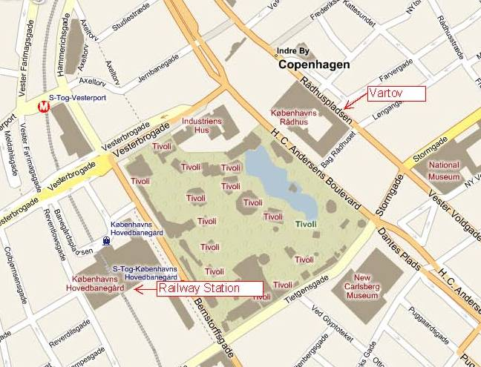

## Mobile numbers of the participants

Bente von Schindel, KSD (DK) (+45) 29 64 70 40

Hans Jørgen Vodsgaard, IF (DK) (+45) 51 300 320

Laraine Winning, VAN (UK) (+44) (0)7818 046 945

AA, VAN (UK)

Dr Janos Szigeti Toth, MNT (HU) (+36) 20 569 66 88

NN, MNT (HU)

Agnieszka Dadak, FAIE (PL) (+48) 511 551 439

Rafał Dadak, FAIE (PL) (+48) 881 676 468

Artur Pinto, MdL (PT)

Manuel Nunes, MdL (PT)

## Aims and key activities of the first meeting

The overall aim of this second partner meeting is to bridge the first and second project phase, summarizing the state of the project and lead the way forward for the partners.

The key activities are:

* To present, discuss and clarify key issues for the Knowledge Portal (WP 02)
* To present, discuss and clarify outcome of the need analysis (WP 03)
* To present, discuss and clarify key issues for the multilateral report (WP 04)
* To present, discuss and outline the initial curricula frame (WP 05)
* To discuss and outline the frame of the national pilot courses (WP 06)
* To decide date and outline the frame of the European pilot courses in Lousada (WP 07)
* To decide date and outline programme of the third partner meeting in Lousada M3)
* To present, discuss and refine the plans the dissemination activities
* To present and refine the Evaluation methods using light versions of Theory of Change
* To clarify guidelines for financial reporting
* To evaluate the preceding work and the current meeting

## Agenda of the meeting (version 4 – 17.04.2017)

**Wednesday, 19 April, 11 – 17:00 (lunch 13 – 14)**

1. Formalities

a) Welcome and practical information

b) Appoint a moderator and a reporter

c) Approval of the agenda

d) Short presentation round (new or extra representatives from organisations may participate)

d) Sign Attendance List

2. Since last time: Info on matters not included in the items below

a) News from the coordinator

b) News from partners

c) Rules of Procedure, by Hans

d) Job-logs/ time-sheets, by Hans

e) Other issues

3. The Knowledge Portal (WP 02) - Present, discuss and clarify key issues

a) Present, discuss and adopt design of the Portal. Intro by Laraine

b) Present, discuss and outline the key content of the Portal. Intro by Laraine

c) Adopt detail task plan for the partnership until third meeting, April – Nov 2017

4. The need analysis (WP 03) - Present, discuss and clarify outcome

a) Round with presentation of local surveys. By all partners

b) Clarify common conclusions of the surveys

5. The multilateral Report, five language ed. (WP 04) - Present, discuss and clarify outline

a) Present the outline. By Bente

b) Clarify guidelines for the recommendations

c) Adopt time schedule for publishing five language editions

6. Integrated Curricula for culture volunteers and managers (WP 05) – Present and outline frame

a) Present the outline for the Curricula Frame. By Hans

b) Clarify guidelines for the frame

c) Adopt time schedule for publishing the integrated curricula, English version

**17:15 – 18:30 City walk / 18:30 – 20:00 Common Dinner**

**Thursday, 20 April, 09 – 12:30**

7. National pilot courses (WP 06) – Discuss and outline guidelines and course frame

a) Outline course frame and testing methods. By Agnieszka

b) Clarify number of participants and budget questions

b) Adopt time schedule for planning and completing the national pilot courses

8. Two European pilot courses in Lousada (WP 07) – Clarify time and frame

a) Outline course frame and testing methods. By Artur

b) Clarify number of participants and course leaders and other budget questions

c) Adopt time schedule for planning and completing the European pilot courses

9. The third partner meeting in Lousada (M3) – Clarify time and frame

10. Dissemination plans (WP 12) – present previous activities and refine future plans

a) Present completed activities. By all partners

b) Refine the dissemination strategy

c) Adopt time schedule for the dissemination activities until third meeting

11. Evaluation methodology (WP 13) - Present, discuss and adopt

a) Present the applied ToC light version. By Helen Clark

b) Discuss and decide guidelines for the subsequent evaluation work

12. Oral Evaluation of current meeting

13. A.O.B. (any other business)

**12.30 – 13:15 Lunch**

**13:30 – 15:30 Individual counselling sessions for all partners from**

**15:30 – 15.45 Farewell**