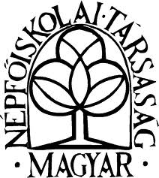

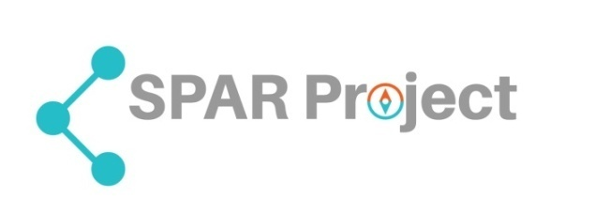**Training for volunteers and mangers of artistic and cultural work**

**Program**

**7-8 July**

**Place: Culture Centre (Kővágóörs, Kossuth u 1.)**

**7 July (Friday)**

Welcome, introductions

Overview on the program

Working with questionnaire: *Exploring previous experiences, knowledge and expectations(see attached)*

The place of non-professional art and cultural activity in community education in Hungary and in Europe. (Sándor Striker PhD Habil Budapest University)

Introduction on the SPAR project (János Szigeti Tóth PhD Budapest University)

**Workshops A**

How can artistic and cultural activities contribute to the quality of life of the local community?

Moderator: Mrs. Erika Hefner

**Workshops B**

Key competencies and skills of art-cultural volunteers and managers.

Moderator: Mr. Lajos Porkoláb

**Workshop C**

Co-operation network locally, communication strategy, supporters, resources

Moderator: Mr.Tamás Kovács

There is a description in national language of the objectives, expected outcome of each workshop.

Each workshop divided 2 parts: 2, 5 hours basic discussion based on preliminary materials and the national survey. Second part 4, 5 hours each, individual, work by pairs, group tasks, exercises settled by the moderators. Free grouping by motivation, interest. In each group will be delegated volunteers and managers working together.

**Free options for working together. (Participants can choose other topics and more too)**

1.Telling good practices (sharing your play) with each other  
2. Making the village's image more attractive with artistic and cultural activities (examples, cases)   
3. Short communication for local radio on the social benefit of local cultural-artistic activities in the community  
4. Artistic activity of children activates adults. Examples

5 What is the benefit of artistic and cultural activity, why it is a benefit?

6. Community issues, art processing and presentation of conflicts  
7. Strengthening art advocacy in the local community (e.g. involving parents)   
8. Benefit to the elderly through culture and art  
9 Drafting a speech for the municipal assembly meeting of the local government  
10.Recruiting volunteers on the village fest (speech draft)   
11. The beneficial impact of culture and art on health (a case)

12. Designing a yearly work of the local cultural association  
13. Organizational guide for an art-cultural event  
14. Interview with local TV (doubles game)  
15. Online application form for recruitment of volunteers (drafting for web)   
16. Formulate an advertisement for the local newspaper (we are waiting for volunteers)  
17. Networking, telephone conversation with a partner organization (paired game)

18: How to Explore Potential Resource Opportunities (plan)   
19. Support request list (from whom and what to ask)

20. Involving disadvantaged people (disabled, ethnic minority etc...)

**8 July Saturday**

**Presentations of the exercises, plans, examples of workshops**

* Summarizing the workshops – co-ordinated by the mediators
* Evaluation *( see the evaluation sheet)*
* Conclusions, formulating suggestions

Looking ahead at home and in the SPAR project. (Selection of candidates for Lousada training)

* Further plans and closing – lunch and leaving