Grundtvig Multilateral project 2009 - 2011: LOAC – Learning outcome of Amateur Culture

Work packet 2.4:
Interviews

Guidelines of interview
with participants and leaders
regarding learning outcome and application

Version 1
Hans Jørgen Vodsgaard
15th of October 2009

Guidelines of interviews

Content
1. Common frame of interviews 2
Guidelines for questions 2
Information to the participants before the interviews 2
2. Learning dimensions and perspectives of application 4
Learning dimensions 4
The application perspective 4
Life quality and learning perspectives 4
3. Relations of learning objectives and application perspectives 5
Possible learning objectives 5
Possible application perspectives 5
4. Used definitions of learning dimensions and elements 6
1. The dimension of personal formation 6
2. The dimension of knowledge & skills 6
3. The dimension of transversal competencies 7

1. Common frame of interviews
The goal is that all organizations conducting interviews following the same guidelines, thus the interviews can be compared and classified in the survey report on learning qualities.
The following guidelines should be
- to conduct a group interview with 2-3 participants (learning recipients) from a typical activity of the association and 1-2 leaders (learning providers). It could be a possibility to divide the interview into two sections, one with participants and another with the leaders;
- to complete the interview in 1-2 hours. It may be advantageous to bring a tape recorder, so it is easier to remember what was said, and it is not necessary to focus on writing memos during the interview;
- to subsequently made a written summary of an article-length (3-5 A4 pages)
- to work from a common disposition of questions.

Guidelines for questions
- Introduction: The interviewer gives a short introduction of the background and aim of the interview.
- Presentation: The participants present briefly themselves and what learning activities they either participate in, or plan and implement as learning providers.
- Perspective of application: The participants explain why they participate, and what they will achieve with it. Hold the focus on the perspective of application: In what spheres of life will they mainly use the learning outcome (in the sphere of work or formal studies as employee-students or in the leisure time as fellow human being or as citizen – categorise by differentiation of homme, citoyen and bourgeois).
- Dimensions of learning: Which dimensions of the learning have priorities for the participants and the providers? Is it personal formation (Bildung), hard knowledge & skills, or soft competencies? Hopefully the interviewers can formulate the outcome in a concrete and imaginative language, because these qualitative formulations will be an important part of the survey report.
- Final recommendations: What can the participants (both the learning receivers and providers) especially recommend that the associations should prioritize in the future learning activities? Which learning outcome do they wish the associations will promote?

Information to the participants before the interviews
Possibly you can send the section 2, 3 and 4 of this memo to the participants before the interview, so they know in advance the understanding and terminology of learning used in the interviews. But it must be left to the judgement of each interviewer.

2. Learning dimensions and perspectives of application
Learning dimensions  Our assessment of the learning outcome by participating in a evening-school course, a folk high school course or an activity in a voluntary association is based on an understanding of learning as consisting of three main dimensions: Formation, knowledge and competencies, and each dimension is determined in turn by an array of 6 elements.  Elements from all three dimensions are a part of all learning processes, but their weight and qualities can and may vary a lot depending on the learning arena and the application perspective. | 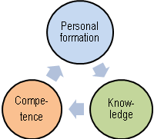
The application perspective  The perspective of a learning activity can be determined through the four spheres of life, as people in modern societies live in, namely  - as a modern man in the personal sphere (in their inner personal relation to themselves)  - as fellow human being in the private and civil sphere of close relationships (in the leisure time)  - as responsible citizenship in the civil and public sphere in civil society and the public affairs (especially in leisure time, but also in work), and  - as an employee in the work time (and as a student in a vocational qualifying education). | 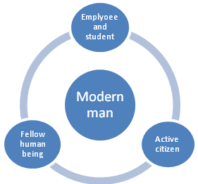

Life quality and learning perspectives
Guidelines for the good life could be to find a balance between the different spheres of life and to achieve the different learning qualities, which is needed in the various spheres of life.
The non-formal adult education and the informal adult learning in amateur culture are characterized by both formation and education, it means both learning for the human life, the societal life and the work life; and the main question for the group interview must be to draw attention to the different qualities and perspectives that the learning receivers and learning providers give special priority:
.Different learning perspectives:
The life in the personal existential sphere - as a self-conscious human being
The life with family, friends and others in the private sphere - as a fellow human being (l’homme)
The life in civil society and the public sphere - as active citizen (citoyen)
The working life - as an employee and employer (bourgeois)
The life in the formal educational system – as student and future employee.

.

3. Relations of learning objectives and application perspectives

Possible learning objectives
- which objectives do the learners and providers prioritize

Knowledge & skills ←→ Personal formation ←→ Competencies

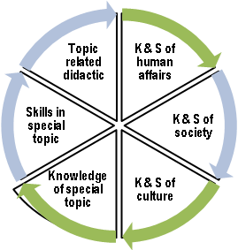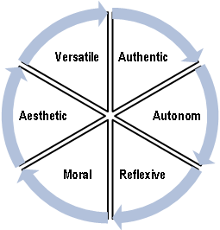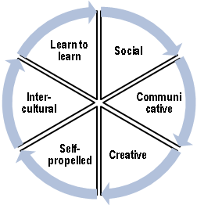

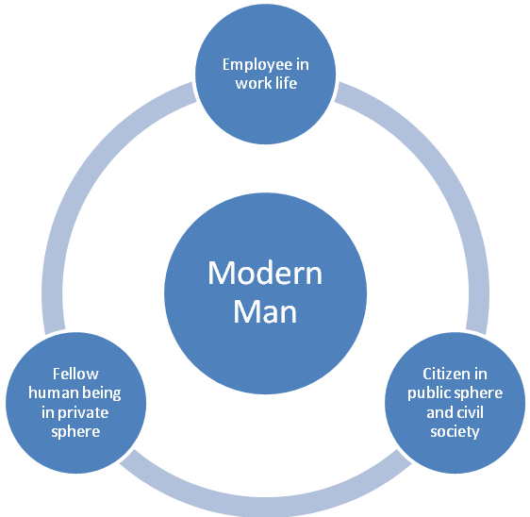

Possible application perspectives
- Which spheres of life do the learners and providers prioritize

4. Used definitions of learning dimensions and elements
In this tool learning is defined by three integrated dimensions, and each dimension is validated by several elements and each element is described by five key words
- Personal Formation (Bildung) with a focus on personal development, where the keywords are authenticity, autonomy, reflexive knowledge, moral sense, aesthetic sense and the whole person
- Qualification with a focus on knowledge and skills, where the keywords are general knowledge about man, society and culture, as well as specific knowledge, skills and didactic understanding within a particular academic subject.
- Competence, with a focus on practical transversal skills, where the keywords are collaboration, communication, creativity and innovation, self-management, intercultural understanding and learning skills.
Elements from the three dimensions are included in one form or another in all learning processes. But their weight and qualities can vary a lot depending on the given learning arena.

1. The dimension of personal formation
1.1 Authenticity
To have authenticity means you are genuine and natural, spontaneous and lively in the sense that”you are yourself”
Key words: Self-esteem, Joy of life, Spontaneity, Vitality, Happiness.
1.2 Autonomy
To have autonomy means that you are autonomous and take a personal stand and dare to follow your own values.
Key words: Self-confidence, Courage of life, Independence (autonomous), Self-determination, Personal attitudes.
1.3 Reflexive knowledge
To have reflexive knowledge means that you have a personal valuation of your knowledge of human conditions, society, culture and nature, and that you can assemble this knowledge into a holistic view of life. In short - that you seek the truth.
Key words: General orientation, Critical learning, Interdisciplinary, (Self-) reflexive, Personal view of life.
1.4 Moral sense
To have moral sense means that you can act as fellow human being in the close relationships and can act as citizen in the larger societal conditions. In short – that you seek the good.
Key words: Empathy, Ethic of reciprocity, Democratic culture, Solidarity, Active citizenship.
1.5 Aesthetic sense
To have aesthetic sense means that you are sensitive, have feeling for moods, can express yourself sensual and poetic, are imaginative and has a developed artistic sense. In short - you are seeking the seeking the beautiful.
Key words: Sensitive of moods, Sensual expressions, Poetic emotions, Imaginative , Artistic sense.
1.6 Versatile personal development
A versatile personal development means that you have self-valued, can integrate reason and emotions, can combine judgements of knowledge, moral and aesthetic, and interact between conscious self-control and intuitive spontaneity. In short – that you are a whole person.
Key words: Self-value (unity of self-feeling and self-confidence), Integrate reason and emotion, Combine judgements of knowledge, moral and aesthetic, Alternate between self-control of autonomy and spontaneity of authenticity. In short - a whole and versatile person with balance of different personal properties.

2. The dimension of knowledge & skills
2.1 General humanistic knowledge and skills
To have general humanistic knowledge and skills means that you are oriented about human conditions, can assess human goals and values, and have the skills to act appropriately as fellow human being in interpersonal situations.
Key words: General knowledge of man, Valuation of human conditions, Personal attitude to human values, Communicate views of human problems, Energetic in interpersonal situations.
2.2 General societal knowledge and skills
To have general societal knowledge and skills means that you are oriented about societal conditions, can assess societal goals and values, and have the skills to act appropriately as active citizen in social and political situations.
Key words: General knowledge of society, Critical valuation of societal conditions and values, Personal attitude to social and political problems, Communicate personal views on social and political problems, Energetic in social and political situations.

2.3 General cultural knowledge and skills
To have cultural knowledge and skills means that you are oriented about cultural conditions, can assess cultural goals and values, and have the skills to act appropriately as human being and active citizen in cultural situations.
Key words: General knowledge of culture, Critical valuation of cultural conditions and values, Personal attitude to cultural problems and possibilities, Communicate personal views on cultural problems, Energetic in cultural situations.
2.4 Knowledge of a specific art based topic
To have knowledge of a specific art based topic means that you have knowledge-related qualifications regarding your main cultural activity.
Key words: Basic theory of my main cultural activity (topic, subject), Knowledge of the disciplines and methods of the topic, Knowledge of the “scientific history” of the topic, Knowledge on performance of the topic, Knowledge of quality standards of the topic.
2.5 Skills in a specific art based topic
To have skills in a specific art based topic means that you have skills-related qualifications regarding your main cultural activity.
Key words: Quality assessment, Technical skills, Skills in using the methods, Skills in technical performance, Artistic expression.
2.6 Didactic of the art based topic
To develop your didactic of the topic means that you know your own learning stile and can choose the learning stile that suit you best. In Short – you learn to learn your topic.
Key words: Learning methods, Pedagogical techniques of teaching, Professional ethics, Awareness of personal learning stile, Responsibility of own learning.

3. The dimension of transversal competencies
3.1 Social competence
To have social competence means that you can interact in communities in a constructive manner.
Key words: Empathic, Participatory, Responsible, Solidarity, Cooperative.
3.2 Communicative competence
To have communicative competences means that you have motivation and ability to communicate with others in a good and appropriate way.
Key words: Like to communicate, Clear and distinct, Use of varied forms of communication, Self-conscious of communicative resources, Change stile of communication according to target group.
3.3 Creative and innovative competence
To be creative and innovative means that you can see new possibilities, easily get new ideas, and have the ability to develop and implement innovations.
Key words: Can see new opportunities, Intuitive, Imaginative, Unorthodox, and Experimental.
3.4 Competence of self-management
To have competence of self-management means that you are good to plan and implement your own tasks.
Key words: Self-propelled, Entrepreneurial, Self-awareness, Risk-willing, Goal-oriented planning.
3.5 Intercultural competence
To have intercultural competences means that you have a wide understanding of different cultures and can understand and interact with people despite cultural differences.
Key words: Openness, Insight in your own culture, Insight in other cultures, Tolerance and respect of diversity, Intercultural cooperation.
3.6 Learning competence
To have learning competence means that you have motivation and ability to continuously learning as human being, citizen and employee, and you know your own learning styles and thus the best ways to acquire new knowledge and skills in different areas.
Key words: Curiosity and joy of learning, Self-discipline and persistence, Motivated for change and development, Awareness of own learning style s, Responsibility of own learning.

