Grundtvig Multilateral project 2009 - 2011: LOAC – Learning outcome of Amateur Culture

Work packet 2.3:
Answered by learners in the organisation
(Participants, students, orther active learners)

Questionnaire:
Valuation of learning profile
by learners

Version 1
Hans Jørgen Vodsgaard
15th of October 2009

Content

Valuation of learning profile 3
Information of background 4
Personal Formation 5
1.1 Education / or Personal Development /authenticity 5
1.2 /autonomy 6
1.3 /reflexive knowledge 7
1.4 /moral sense 8
1.5 /aesthetic sense 9
1.6 /the versatile personal development 10
Knowledge and skills 11
2.1 Knowledge and skills/about human conditions and values 11
2.2 Knowledge and skills/ about societal conditions and values 12
2.3 Knowledge and skills/about cultural conditions and values 13
2.4 Knowledge and skills/ knowledge of the profession 14
2.5 Knowledge and skills/skills of the profession 15
2.6 Knowledge and skills/didactic of the profession 16
Competences 17
3.1 Competences/social 17
3.2 Competences/communicative 18
3.3 Competences/creativity and innovation 19
3.4 Competences/self-management 20
3.5 Competences /intercultural 21
3.6 Competences/learning ability 22
Possible comments 23

Valuation of learning profile
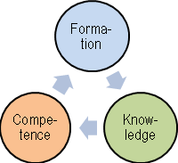
Learning has in recent years become a central concept in pedagogy, education and NGO activities. Learning takes place in formal education from primary school to university, in non-formal education such as popular adult education and as informal learning such as voluntary activities in civil society.
Here you shall valuate your learning profile by three dimensions:
- Personal development (personal education)
- Knowledge & skills
- Competences
Each dimension is validated by six elements and each element is described by five key words
1. Education / or Personal development
1.1 Authenticity | Self-esteem, joy of life, spontaneity, vitality and happiness
1.2 Autonomy | Self-confidence, civil courage, self-determination, personal attitudes, autonomous
1.3 Reflexive | General orientation, interdisciplinary, critical, self reflection, personal view of life
1.4 Moral sense | Emphatic, ethic of reciprocity, democratic culture, solidarity, active citizenship
1.5 Aesthetic sense | Sensitivity, sensuality, poetic, emotional, imagination
1.6 Versatile person  (a whole person) | Self-value; Integrate reason and feeling; combine knowledge, moral and aesthetic; interact between control and spontaneity

Knowledge & skills
2.1 Knowledge & Skills of  human conditions and values | Knowledge, valuation, attitude, communicate and energetic  regarding human conditions and values
2.2 Knowledge & Skills of  social conditions and values | Knowledge, valuation, attitude, communicate and energetic  regarding social conditions and values
2.3 Knowledge & Skills of  cultural conditions and values | Knowledge, valuation, attitude, communicate and energetic  regarding cultural conditions and values
2.4 Knowledge in main topic | Theory, history, methods, techniques, quality standards in your main topic
2.5 Skills in main topic | Quality assessment, technical skills, methodical skills, performance, artistic skills
2.6 Didactic of topic | Learning method of topic, ethics of topic, awareness of personal learning stile, responsibility of own learning

Competences
3.1 Social competence | Empathic, participatory, accountably, solidaric, cooperative
3.2 Communicative  competence | Like to communicate, clear, versatile, self-conscious, manage to change style
3.3 Creative and innovative  competences | See new opportunities, intuitive, imaginative, unorthodox, experimental
3.4 Competence  of self-management | Self-propelled, entrepreneurial, self-awareness, risk-willing, purposeful planning
3.5 Intercultural competence | Curiosity, cultural insight, tolerance, flexibility, respect of diversity
3.6 Learning competence | Likes to learn, self-discipline, persistent, awareness of own learning styles, responsibility of own learning
Elements from the three dimensions are included in one form or another in all learning processes. But their weight and qualities can vary a lot depending on the given learning arena.
Here we wish to clarify and valuate the learning qualities in your organization's activities.
By answering this questionnaire you will get a documentation of your actual learning profile, and a valuation of what degree of influence the participation in your associations activities have had on your learning profile.
Enjoy yourself - start on the series of questions.

Information of background
This information can help us to valuate, if factors such as nationality, type of organization, role in the organization, gender, age and education implies clear differences in the answers on the subsequent questions about objectives, values and learning qualities.

a | Your organisation is based in which country?
a | Name of the organisation
a | Name of possible department

b | The main activity in the organization,  which you participate in?  (describe briefly)

c | Gender | Male | Female
c | I am .. (tick one box)

d | Age | 15 – 17 years | 18 – 29  years | 30 – 39 years | 40 – 49 years | 50 – 59  years | 60 – 69 years | 70 – 99  years
d | My age are .. (tick one box)

e | Educational background | Primary School  (7 – 15 year) | Gymnasium  (16 – 19 year) | Technical vocational education  (16 – 19 year) | Short higher education  (1-2 year) | Middle higher education  (3-4) | Longer Higher  education  (4-7 år) | Other
e | My highest education is .  (tick one box)

f | Occupation | Private  sector | Public  sector | Civil society  (Associations  or institutions) | Full time  student | Out of work  (retirement etc) | Other
f | My occupation is ..  (Tick one box)

Education / Personal Development

1.1 Education / Personal Development/authenticity |  | 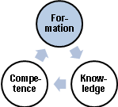
The first element of education / personal development is authenticity.  To have authenticity means you are genuine and natural, spontaneous and lively in the sense that ”you are yourself”  The key words are  - Self-esteem  - Joy of life  - Spontaneity  - Vitality  - Happiness | 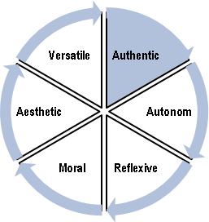

Assessment of your learning profile  Here you must assess your degree of authenticity.  Indicate in which degree the statements apply to you. (Tick one box for each statement). | Very low degree | Low degree | Some degree | IHigh degree | Very high degree
I am feeling good to be myself
I am happy to live and feel me at home in the world
I find it easy to act spontaneously and unconstrained.
I am often engaged in a self-forgetting manner.
I experience that my life has meaning in itself, and I have value as I am.

The learning benefits of the activities of the association
Indicate in which degree the activities in your association have developed your authenticity?

1.2 Education or Personal Development /autonomy
The second element of education or personal development is autonomy.  To have autonomy means that you take a personal stand and dare to follow your own values.  The key words are  - Self-confidence  - Courage of life  - Independence (autonomous)  - Self-determination  - Personal attitudes | 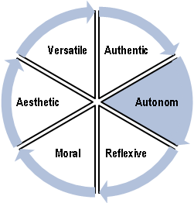
k
Assessment of your learning profile  Here you must assess your degree of autonomy.  Indicate in which degree the statements apply to you. tick one box for each statement) | Very low degree | Low degree | Some degree | High degree | Very high degree
I have courage in life
I am confident that I can create change and make a difference
I trust on my own judgement
I follow my own values and attitudes
I can stand by my actions

The learning benefits of the activities of the association
Indicate in which degree the activities in your association have developed your autonomy?

1.3 Education or personal development /reflexive knowledge
The third element of education or personal development is reflexive knowledge.  To have reflexive knowledge means that you have a personal valuation of your knowledge of human conditions, society, culture and nature, and that you can assemble this knowledge into a holistic view of life.  The key words are  - General orientation  - Critical learning  - Interdisciplinary  - Reflexive and self-reflexive  - Personal view of life | 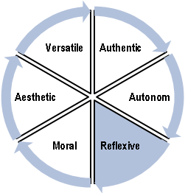

Assessment of your learning profile.  Here you must assess your degree of reflexive knowledge.  Indicate in which degree the statements apply to you. (Tick one box for each statement). | Very low degree | Low degree | Some degree | High degree | Very high degree
I have a general knowledge of society, culture and nature.
I am good to acquire extensive knowledge on selected topics
I am good in getting an overview and seeing connections between different fields of knowledge
I can (self-) critically assess the value of my knowledge and my opinions
I have a personal perspective on my acquired knowledge

The learning benefits of the activities of the association
Indicate in which degree the activities in your association have developed your reflexive knowledge?

1.4 Education or personal development /moral sense
The fourth element of education or personal development is moral sense.  To have moral sense means that you can act as fellow human being in close relationships and act as citizen in larger social conditions.  The key words are  - Empathy  - Ethic of reciprocity  - Democratic culture  - Solidarity,  - Active citizenship | 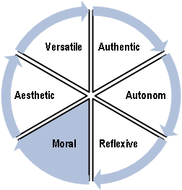

Assessment of your learning profile.  Here you must assess your degree of moral sense. .  Indicate in which degree the statements apply to you. (Tick one box for each statement). | Very low degree | Low degree | Some degree | High degree | Very high degree
I am emphatic to other person’s conditions and can act with compassion towards them
I act towards others as I want them to act against me.
I appreciate an equal community characterised of trust and dialogue
I feel a responsibility to the communities I am part of.
I have an attitude to the main political and social issues

The learning benefits of the activities of the association
Indicate in which degree the activities in your association have developed your moral sense?

1.5 Education or personal Development /aesthetic sense
The fifth element of education or personal development is aesthetic sense.  To have aesthetic sense means that you are sensitive, have feeling for moods, can express yourself sensual and poetic, are imaginative and have a developed artistic sense.  The key words are  - Sensitive of moods  - Sensual expressions  - Poetic emotions  - Imaginative  - Artistic sense | 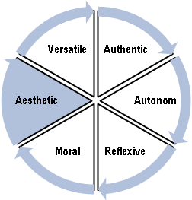

Assessment of your learning profile.  Here you must assess your degree of aesthetic sense.  Indicate in which degree the statements apply to you. (Tick one box for each statement). | Very low degree | Low degree | Some degree | High degree | Very high degree
I have a developed sense of moods and emotional meanings
I can communicate experiences by means of body language and other sensual expression
I can express myself through poetic imagery and narratives
I can use my imagination, when I seek for new opportunities
I have developed my taste and judgement in relation to artistic quality

The learning benefits of the activities of the association
Indicate in which degree the activities in your association have developed your aesthetic sense?

1.6 Education or personal development /the versatile personal development
The sixth element of education or personal development is the versatile personal development (a whole person).  A versatile personal development means that you feel self-value, can integrate reason and emotions, can combine judgements of knowledge, moral and aesthetic, and interact between conscious self-control and intuitive spontaneity.  The key words are  - Self-value (unity of self-feeling and self-confidence)  - Integrate reason and emotion  - Combine judgements of knowledge, moral and aesthetic  - Alternate between self-control of autonomy and spontaneity of authenticity  - A whole and versatile person with balance of different personal properties | 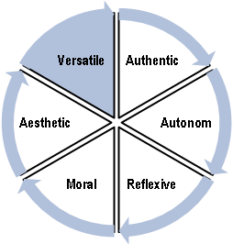

Assessment of your learning profile.  Here you must assess your degree of versatile personal development.  Indicate in which degree the statements apply to you. (Tick one box for each statement). | Very low degree | Low degree | Some degree | High degree | Very high degree
I have a high self-value (defined as a unity of self-feeling and self-confidence)
I can both use my reason and my feelings
My judgement is based both on my knowledge, moral and aesthetic sense.
I can alternate between self-conscious management and self-forgetful preoccupation with situations
I see myself as a whole and harmonious person

The learning benefits of the activities of the association
Indicate in which degree the activities in your association have developed your versatile personal development?

Knowledge and skills

2.1 Knowledge and skills/about human conditions and values |  | 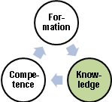
The first element of knowledge & skills is your general knowledge and skills about human conditions and values  To have human knowledge and skills means that you are oriented about human conditions, can assess human goals and values, and have the skills to act appropriately as fellow human being in interpersonal situations.  The key words are  - General knowledge of man  - Valuation of human conditions  - Personal attitude to human values  - Communicate views of human problems  - Energetic in interpersonal situations | 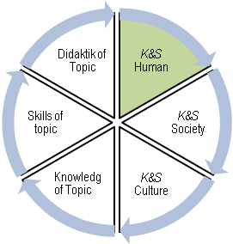

Assessment of your learning profile.  Here you must assess your degree of knowledge and skills regarding human conditions and values.  Indicate in which degree the statements apply to you. (Tick one box for each statement). | Very low degree | Low degree | Some degree | High degree | Very high degree
I have a high general knowledge of human behaviour, values and opportunities
I can critically valuate different views on human condition and values
I can express a personal opinion on concrete human problems
I can communicate my views and attitudes in a clear manner
I am good to act in difficult interpersonal situations.

The learning benefits of the activities of the association
Indicate in which degree the activities in your association have developed your knowledge and skills about human conditions and values?

2.2 Knowledge and skills/ about social conditions and values
The second element of knowledge & skills is your general knowledge and skills about  social conditions and values.  To have social knowledge and skills means that you are oriented about social  conditions, can assess social goals and values, and have the skills to act appropriately  as active citizen in social and political situations.  The key words are  - General knowledge of society  - Critical valuation of social conditions and values  - Personal attitude to social and political problems  - Communicate personal views on social and political problems  - Energetic in social and political situations | 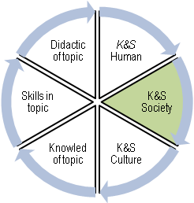

Assessment of your learning profile.  Here you must assess your degree of knowledge and skills about societal conditions and values.  Indicate in which degree the statements apply to you. (Tick one box for each statement). | Very low degree | Low degree | Some degree | High degree | Very high degree
I have a high general knowledge of social conditions
I can critically valuate different views on political values
I can express a personal opinion on concrete social problems
I can communicate my views and attitude on social problems in a clear manner
I can act politically in relation to social problems

The learning benefits of the activities of the association
Indicate in which degree the activities in your association have developed your general knowledge and skills about social conditions and values?

2.3 Knowledge and skills/about cultural conditions and values
The third element of knowledge & skills is your general knowledge and skills about cultural conditions and values.  To have cultural knowledge and skills means that you are oriented about cultural conditions, can assess cultural goals and values, and have the skills to act appropriately as human being and active citizen in cultural situations.  The key words are  - General knowledge of culture  - Critical valuation of cultural conditions and values  - Personal attitude to cultural problems and possibilities  - Communicate personal views on cultural problems  - Energetic in cultural situations | 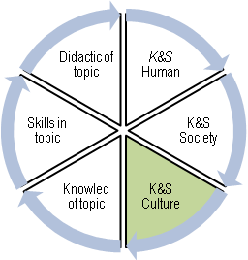

Assessment of your learning profile.  Here you must assess your degree of knowledge and skills about cultural conditions and values.  Indicate in which degree the statements apply to you. (Tick one box for each statement). | Very low degree | Low degree | Some degree | High degree | Very high degree
I have a high general knowledge of cultural conditions
I can critically valuate different views on cultural values
I can express a personally opinion on concrete cultural problems
I can communicate my views and attitude on cultural problems in a clear manner
I can act in relation to intercultural problems

The learning benefits of the activities of the association
Indicate in which degree the activities in your association have developed your general knowledge and skills regarding cultural conditions and values?

2.4 Knowledge and skills/ knowledge of the profession
The fourth element of knowledge & skills is your professional knowledge of your main cultural activity in the association (the professional subject or topic).  To have professional knowledge means that you have knowledge-related qualifications regarding your main cultural activity.  The key words are  - Basic theory of my main cultural activity (topic, subject)  - The disciplines and methods of the topic  - The “scientific history” of the topic  - Knowledge on performance of the topic  - Knowledge of quality standards of the topic | 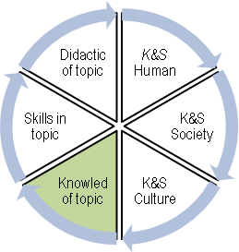

Enter your main topic

Assessment of your learning profile  Here you must assess your degree of professional knowledge of your main cultural activity.  Indicate in which degree the statements apply to you. (Tick one box for each statement). | Very low degree | Low degree | Some degree | High degree | Very high degree
I know the basic theories of my topic
I know the methods and disciplines of the topic
I know the historical development of the topic.
I know the main techniques of the topic
I know the quality standards of the topic

The learning benefits of the activities of the association
Indicate in which degree the activities in your association have developed your professional knowledge of your main cultural activity?

2.5 Knowledge and skills/skills of the profession
The fifth element of knowledge & skills is your professional skills in your main cultural activity in the association (the professional subject or topic).  To have professional skills means that you have skills-related qualifications regarding your main cultural activity.  The Key words are  - Quality assessment  - Technical skills  - Skills in using the methods  - Skills in performance  - Artistic expression | 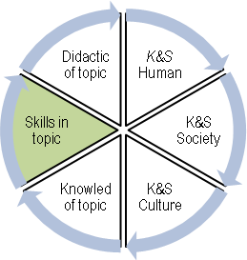

Assessment of your learning profile  Here you must assess your degree of professional skills in your main cultural activity.  Indicate in which degree the statements apply to you. (Tick one box for each statement). | Very low degree | Low degree | Some degree | High degree | Very high degree
I can evaluate the quality of a performance in my main cultural activity
I have good skills in the techniques of the topic
I have good skills in the methods and various disciplines of the topic
I can combine my techniques with a god personal performance
I have a developed artistic expression when I perform

The learning benefits of the activities of the association
Indicate in which degree the activities in your association have developed your professional skills in your main topic?

2.6 Knowledge and skills/didactic of the profession
The sixth element of knowledge & skills is the didactic of the cultural activity (the professional subject or topic).  To develop your didactic of the topic means that you know your own learning stile and can choose the learning stile that suit you best.  The key words are  - Learning methods  - Pedagogical techniques of teaching  - Professional ethics  - Awareness of personal learning stile  - Responsibility of own learning | 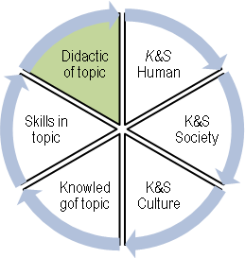

Assessment of your learning profile.  Here you must assess your degree of didactical knowledge and skills of your main topic.  Indicate in which degree the statements apply to you. (Tick one box for each statement). | Very low degree | Low degree | Some degree | High degree | Very high degree
I have good insight into artistic teaching methods
I have a broad understanding of various learning and teaching practices in the subject.
I have a broad understanding of professional ethics and standards of the subject.
I have a good (self-) understanding of the kinds of learning in the subject that best fits me.
I am good in using my favourite forms of learning in the subject

The learning benefits of the activities of the association
Indicate in which degree the activities in your association have developed your didactical knowledge and skills of your main topic?

søg

Competences

3.1 Competences/social |  | 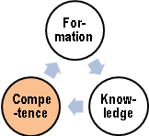
The first element of competences is the social competence.  To have social competences means that you can interact in communities in a constructive manner.  The key words are  - Empathic  - Participatory  - Responsible  - Solidarity  - Cooperative | 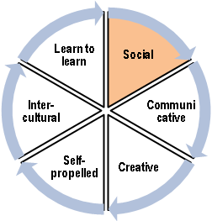

Assessment of your learning profile  Here you must assess your degree of social competences.  Indicate in which degree the statements apply to you. (Tick one box for each statement). | Very low degree | Low degree | Some degree | High degree | Very high degree
I can familiarize myself with another person’s problems and needs
I can involve others in solving a common task
I take responsibility to resolve common challenges
I can create unity and loyalty among people
I can cooperate with a wide range of different people

The learning benefits of the activities of the association
Indicate in which degree the activities of your association have developed your social competences?

3.2 Competences/communicative
The second element of competences is the communicative competence.  To have communicative competences means that you have motivation and ability to  communicate with others in a good and appropriate way.  The Key words are  - Like to communicate  - clear and distinct  - Use of varied forms of communication  - Self-conscious of communicative resources  - Change stile of communication according to target group | 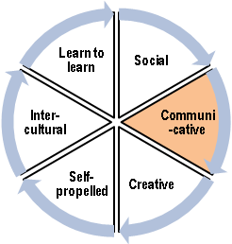

Assessment of your learning profile  Here you must assess your degree of communicative competences.  Indicate in which degree the statements apply to you. (Tick one box for each statement). | Very low degree | Low degree | Some degree | High degree | Very high degree
I like to communicating with others
I can give a clear and distinct message to other people
I can use a variety of different communication techniques
I can choose the most appropriate form of communication in the given situation
I can change my communication style according to where and with whom I communicate

The learning benefits of the activities of the association
Indicate in which degree your association’s activities have developed your communicative competences?

3.3 Competences/creativity and innovation
The third element of competences is the creative and innovative competences.  To be creative and innovative means that you can see new possibilities, easily get new ideas, and have the ability to develop and implement innovations.  The key words are  - Can see new opportunities  - Intuitive  - Imaginative  - Unorthodox  - Experimental |  | 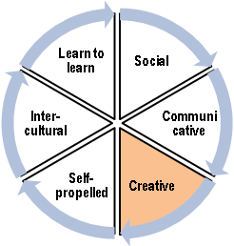

Assessment of your learning profile  Here you must assess your degree of creative and innovative competences.  Indicate in which degree the statements apply to you. (Tick one box for each statement). | Very low degree | Low degree | Some degree | High degree | Very high degree
I can see new possibilities when a task has to be solved
I can use my intuition to prioritise plans
I can use my imagination to solve problems
I like to develop new ideas
I like to experiment and test alternative solutions

The learning benefits of the activities of the association
Indicate in which degree the activities of your association have developed your creative and innovative competences?

3.4 Competences/self-management
The fourth element of competences is the competence of self-management.  To have competence of self-management means that you are good to plan and implement your own tasks.  The key words are  - Self-propelled  - Entrepreneurial  - Self-awareness  - Risk-willing  - Goal-oriented planning | 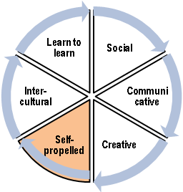

Assessment of your learning profile.  Here you must assess your degree of self-management competence.  Indicate in which degree the statements apply to you. (Tick one box for each statement). | Very low degree | Low degree | Some degree | High degree | Very high degree
I can motivate myself to an extensive effort
I take the initiative to solve various problems encountered
I can assess my own strengths and weaknesses in relation to a task
I am willing to take risks to achieve difficult goals
I can plan and implement my own tasks

The learning benefits of the activities of the association
Indicate in which degree the activities of your association have developed your competence of self-management?

3.5 Competences /intercultural
The fifth element of competences is the Intercultural competence.  To have intercultural competences means that you have a wide understanding of different cultures and can understand and interact with people despite cultural differences.  The Key words are  - Openness  - Insight in your own culture  - Insight in other cultures  - Tolerance and respect of diversity  - Intercultural cooperation | 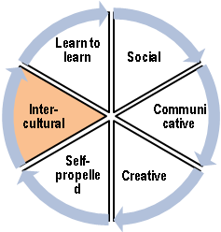

Assessment of your learning profile  Here you must assess your degree of intercultural competence.  Indicate in which degree the statements apply to you. (Tick one box for each statement). | Very low degree | Low degree | Some degree | High degree | Very high degree
I find it exciting to meet people from other cultures
I know my own culture and its differences from other cultures
I have insight into common human values across cultural differences
I think we should meet each other with tolerance and respect for diversity
I can deal with people from different backgrounds and different cultures

The learning benefits of the activities of the association
Indicate in which degree the activities of your association have developed your intercultural competence?

3.6 Competences/learning ability
The sixth element of competences is the learning ability.  To have learning ability means that you have motivation and ability to continuously learning as human being, citizen and employee, and you know your own learning styles and thus the best ways to acquire new knowledge and skills in different areas.  The key words are  - Curiosity and joy of learning  - Self-discipline and persistence  - Motivated for change and development  - Awareness of own learning styles  - Responsibility of own learning | 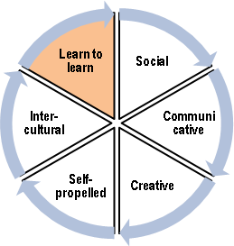

Assessment of your learning profile  Here you must assess your degree of learning ability.  Indicate in which degree the statements apply to you. (Tick one box for each statement). | Very low degree | Low degree | Some degree | High degree | Very high degree
I like the process of learning, even though I can’t use the result for personal gain
I don’t give up, when I want to learn something new, even though it is difficult
I like to learn something new that can change my understanding of the world or other persons
I am conscious of how I learn best
I take responsibility for what I want to learn and how I will do it

The learning benefits of the activities of the association
Indicate in which degree the activities of your association have developed your learning ability?

.

Possible comments
If you have comments or critics of the questionnaire, or want to explain your answers, you are welcome to write them below
General comments:
Questions about education or personal development:
Questions about knowledge and skills:
Questions about competences:

Thank you for participating in our survey

