Invitation to the free online conference

**„Micropolis – The Power of Local Community”**

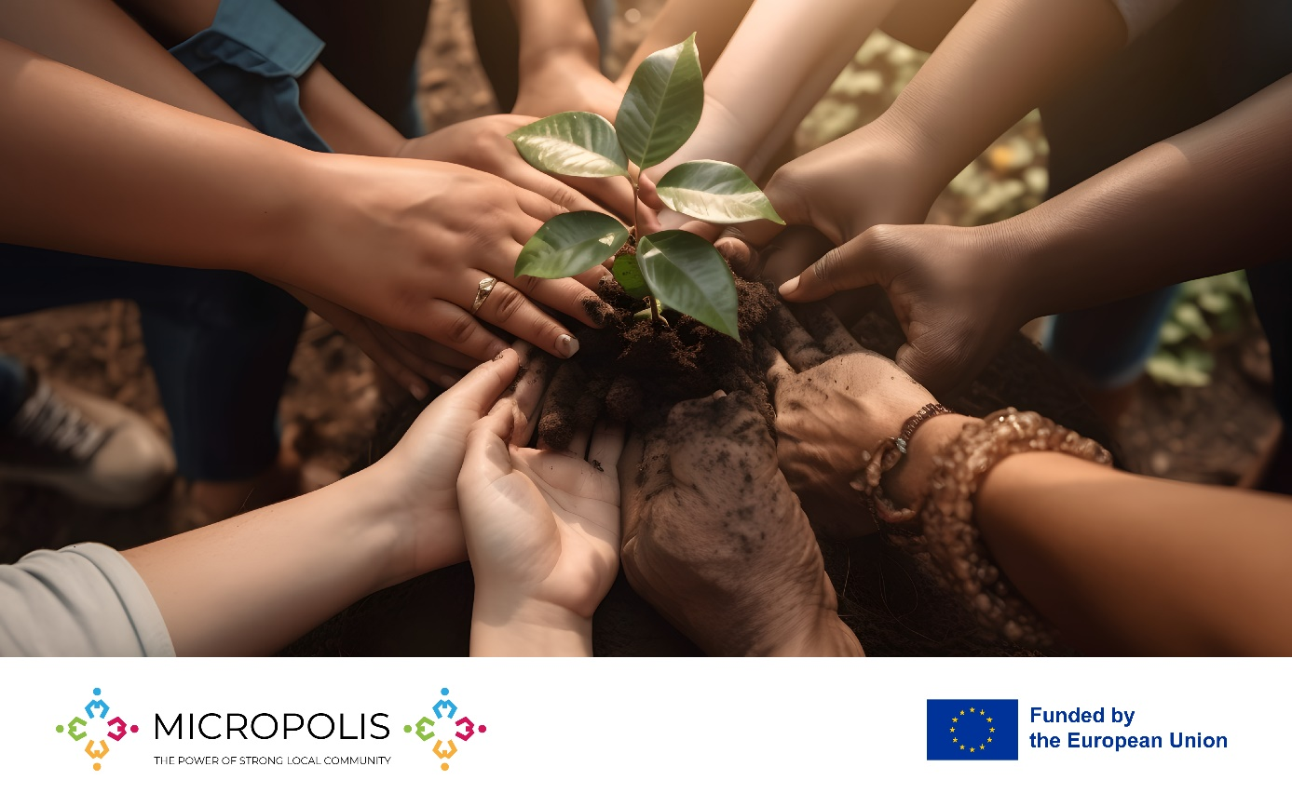

When: **12th September (Thursday) at 11 am** (Polish/Danish Time**)/ 12 am** (Finish Time)

How to join: Register online at ……..(new form or we can change this form into a conference registration: https://micropolis.club/join-the-club/)

We cordially invite all active citizens - local activists, members of NGO’s, journalists, employees of Culture Houses, Libraries, Schools and City Halls and **everybody who is interested in builiding strong local communities** **– to the unique online conference** that is the culmination point and the celebration of the EU-funded project - small scale partnership from Erasmus+ Program entitled „Micropolis 2023 – the power of strong local community”.

We created the name Micropolis to describe a local community, a city district or a town that has successfully created it’s strong, inclusive local identity and an active participation and cooperation of inhabitants, so that they can function as ancient „polis” – the fully democtratic, local community where everybody is involved

During the conference we will share our experience and refections from the project – what ways of creating and strenghtening the local communities we find the most effective and successful. We will present the Micropolis Guidebook that combines the Case Studies, the surveys results and the examples of practical implementations of Micropolis concept within the local communities or organisations’ network.

We also intend to create some international networking possibilities for all the conference participants.

Let us inspire you with the Micropolis idea!

Conference program:

11 am – 11:20 am: Malgorzata Smoczynska (Poland) – „Micropolis – idea, project and the Guidebook”

11:20 am – 11:40 am: Hans Jørgen Vodsgaard (Denmark) – „Practical aspects of Micropolis project works in Middelfart and the value of international cooperation”

11:40 am – 12:00 am: Pentti Lemmetyinen (Finland) -“Power of People – How to strengthen active citizenship”

12:00 am – 12:30 pm: networking space for participants

About the Speakers:

Malgorzata Smoczynska - Project main leader, author and coordinator. Working as EU-projects creator and coordinator for Wawerskie Centrum Kultury (public culture institution in Wawer district of Warsaw) and Varsovia Educational Foundation, experienced in several EU-Projects..

Hans Jørgen Vodsgaard - Chief Executive for Interfolk Institute. Experienced in project coordination, desk and field research, pilot work implementation, curricula and course planning, and evaluation and quality assurance – in a Nordic-Baltic and European civil society context. He is also author of articles, reports, and books in the field of liberal adult education and participatory arts and voluntary culture in a civil society context.

Pentti Lemmetyinen – the President of the International Settlement Federation (IFS) since 2016, with more than 30 years of work experience in The Finnish Federation of Settlement Houses that has 32 member organisations all over Finland. Pentti is also a member of the board of the Finnish United Nations Association and chairman of Finnish Victim Support Work.

More information and the free-access Micropolis Guidebook: [www.micropolis.club](http://www.micropolis.club)

The conference starts at 11 am Polish/Danish Time (UTC+2). All the details will be sent via e-mail for all registered participants.

Please register here: ….