

**IFS examples on fostering social cohesion and active citizenship**

* Case studies from Sweden, Hungary, France and Finland

By Junias Kanyinda, IFS Communication officer and Staffan Lindqvist, IFS Executive Director

**Table of content**

Introduction 1

Case study I; All Activity Houses - Malmö, Sweden 2

Case study II; Neighbourhood Volunteers - Debrecen region, Hungary 4

Case study III; Outreach work – Bretagne, France 7

Case study IV; Kalliola Setlementti – Helsinki, Finland 9

Perspectives from the case studies 11

**Introduction**

The International Federation of Settlements and Neighbourhood Centres (IFS) is the leading organisation for Neighbourhood Centres around the world. The first Settlement House, “Toynbee Hall” in London, was founded in 1884 to strive to bridge the gap between people of all social and financial backgrounds, with the aim of working towards a future without poverty and was based on self-help, community action and welfare rights.

As the movement grew, a platform for global coordination and exchange of good practice was needed and IFS was founded in 1926. Today, IFS has nearly 11,000 local organizations, with members in 33 countries on six continents and the IFS head office is currently hosted by the Finnish Federation of Settlement houses in Helsinki.

The following four case studies is a selection of examples of the vast experiences of community work aimed at social cohesion and active citizenship within the IFS network.

](https://youtu.be/oeqZafjobMg)

**Case study I: All Activity Houses in Malmö, Sweden**

* using public schools as local Community Centers

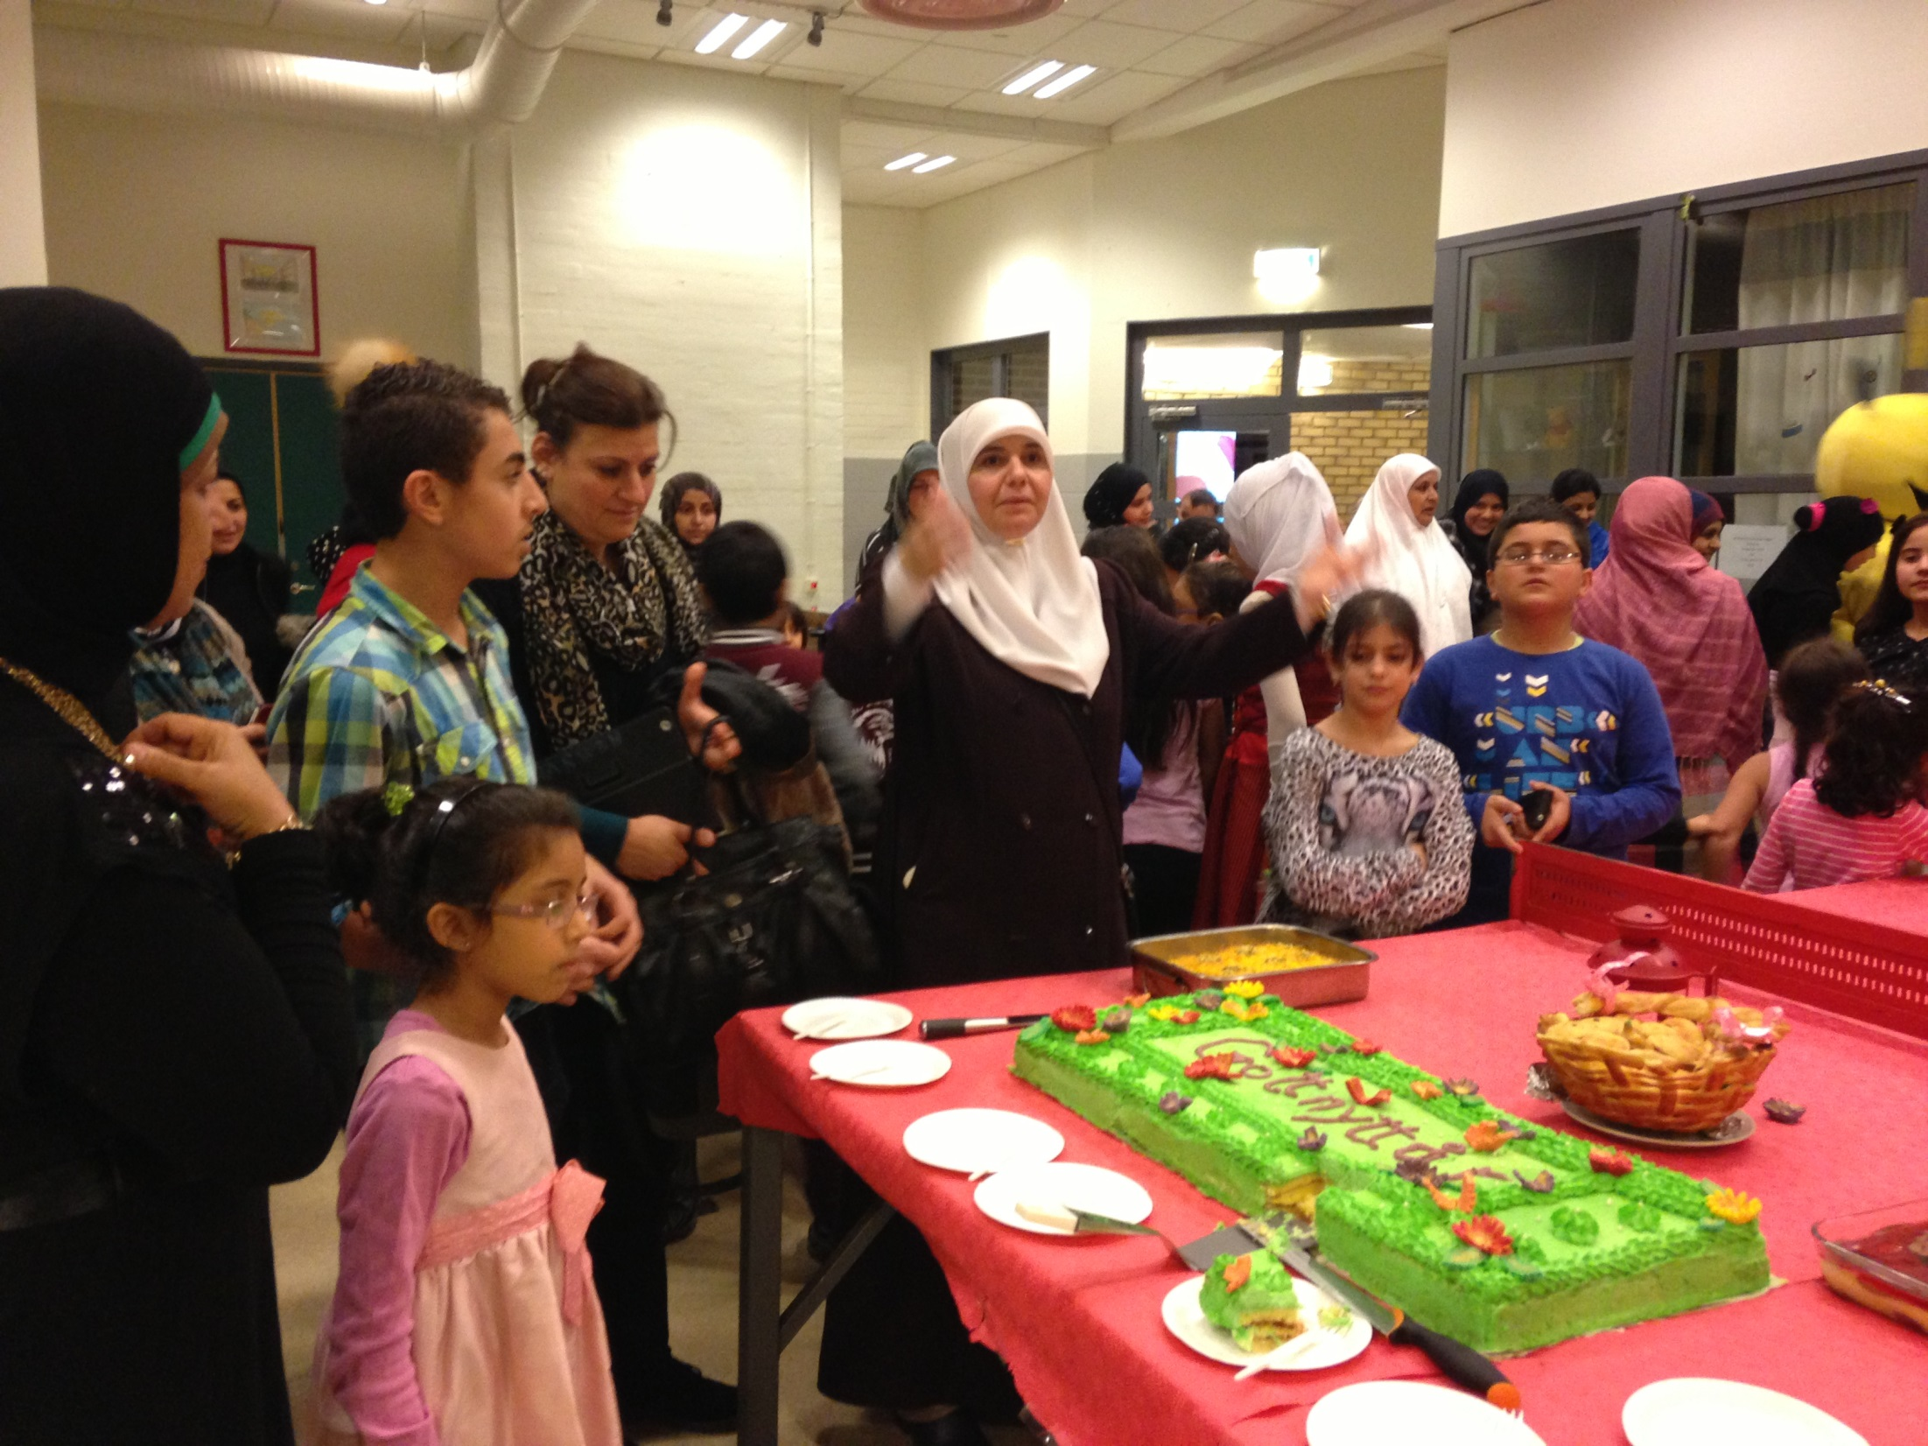

**Background and objectives**

The All Activity Houses (AAH) are part of the municipal organization of the city of Malmö and are sorted under the cultural department. The first AAH started in 2011 as a project in the area Lindängen in Malmö and was established in conjunction with an ongoing area-based EU project.

 The idea was created from the circumstances in the area which where a high experience of insecurity both in the school and in the local area, low employment rate, high crime rate, few local meeting places, a lack of official voluntary and local associations and structural barriers that specifically hinder girls and women abilities to participate in cultural and leisure activities. As part of the existing community work the organization has from start relied on cooperation with the local educational and cultural departments, housing companies, local businesses and civil society organizations.

Activities are used as a tool to build relations, foster social cohesion, active citizenship and social capital; it is not the activity per se but the effects of the activity that is the most valuable. The relationships, the trust and the feeling of togetherness is the essence.

**Methods and activities**

The All Activity House (AAH) is a concept which contains many tools. The basic idea is to use the local *school as a centre for community work*. All children and youth in the community are offered activities in direct connection to the school day and in evenings and weekends also families and adults. Many of the immigrant girls are expected to stay at home after school to help out and also for protection. But when there is a possibility to go to the activities directly after school without going home first, it is more like a prolonging of the school day and this makes it possible for also the girls to take part in the activities.

All activities are *free of charge*, all activities are *demanded by the residents* and all wanted activities will start one week, at the lates, after it has been demanded or wished for. The staff also work during the whole school day, have activities in breaks and cooperates with the teachers. The activities with the children is a way to make contact with parents and has become a way to create a community center for all residents in the area.

The staff in AAH is deliberately a mixture of persons with *different backgrounds and educations*. All new staff persons get an education in how to think and work in a *potential oriented* way, to focus on possibilities and not on obstacles. This gives them a common foundation on how to work together and meet the residents.

The staff cooperate very closely with the teachers in the school and use children and youth as co-leaders. They offer activities for free to all residents and only start activities that are asked for and they start all activities that are asked for. Every week all activity leaders call the parents of at least two children and tell them about good things that their child has been doing during the week. This is one of the way to build confidence and make contacts to adult residents.

Except for the good thing to be able to use all premises in school, there are another successful reason to use the school. Most residents are immigrants and the first Swedish authority they get in real contact with and get confidence in is the school. This makes it easier to reach and achieve trustful relations to the residents.

The starting point is as mentioned what the local citizen wishes but you cannot wish something that you don’t know of. Because of that they create opportunities for new experiences. For example, introducing something is often done with known leaders or on a known locations to make trying something new less scary. Furthermore, children’s rights and democratic values are the basis of the organization, the participant learns about their rights and how they can be used but also gets a routine of getting involved and affecting the outcome. Besides this gender equality is of high prioritizing, to reach as many girls as boys more activities specifically for girls are offered though we can see that they have fewer possibilities to have a meaningful leisure time.

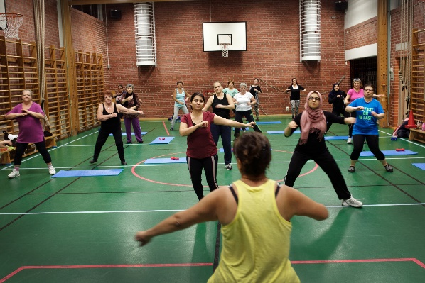 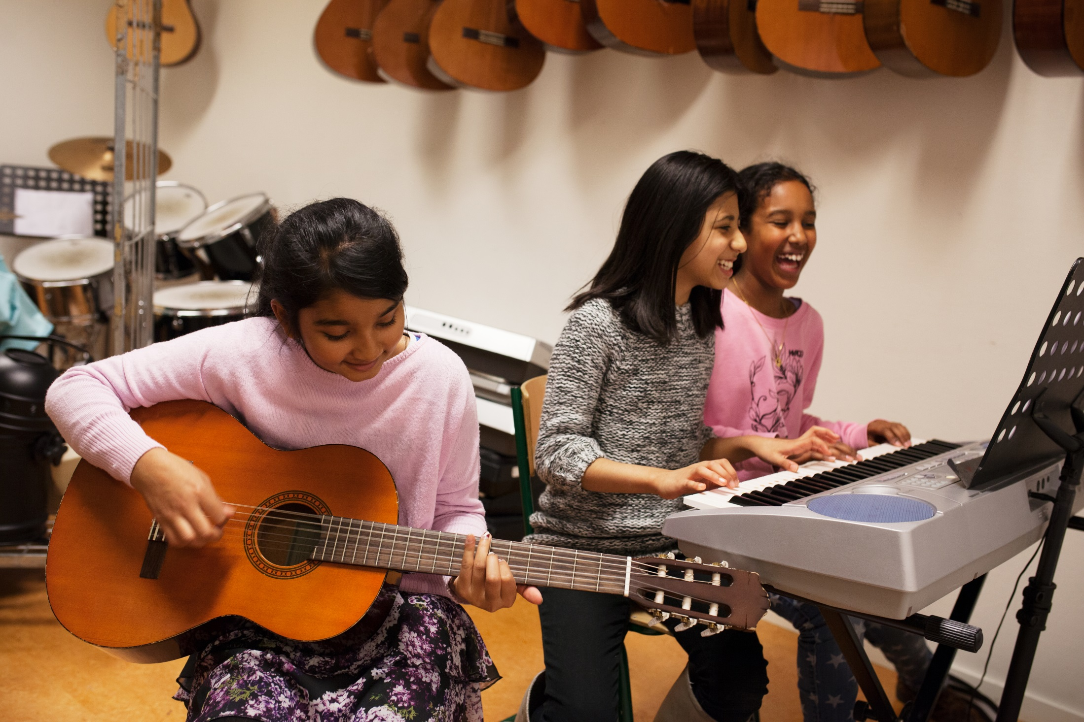

**Results/Impact/Learning**

The positive effects of the first All Activity House in Lindängen, was among others a raise of the students grades and a higher feeling of security among all residents. It has also led to significant less damage in the area and the main Housing company decided to build more apartment houses in the area due to the positive atmosphere in the area and to bigger demand for apartments.

In Malmö, the AAH is used in socially disadvantaged areas with a very high rate of immigrants with low income and high rate of unemployment. However, the idea of using the school as a community centre, to cooperate closely with the school and culture department and to have a potential oriented approach can most certainly be used in any local community to promote social inclusion and cohesion and active citizenship. Of course, the concept must be modified out of the local context, like prerequisites and needs.

A benefit with the AAH are also that due to the location within the school, more adults together create a safer school environment. It enables teachers to focus on their core assignments and the staff contributes to the daily work in making sure that all children are seen and heard. Activities stimulate both movement and creativity but also improve group dynamics and give positive effects that spill over during lecture time. The participants describe it as bringing something positive to the school, activities to look forward to and a place to go if one needs help or just to say “Hi”. The presence of AAH brings a calm and familiar vibe to the school and creates an atmosphere where everyone is welcome to join and be themselves. Furthermore, the community work strengthens the local community but also the individual in terms of giving opportunities for participation, tools that increases ability to voice one’s thoughts and strives to spread knowledge in human rights and how these rights can be used. Together with the local citizens, AAH builds fellowship that create positive long-term impact in the community and strives to improve the possibilities to have meaningful activities, learn new things and experience new contexts.

**Key success factors**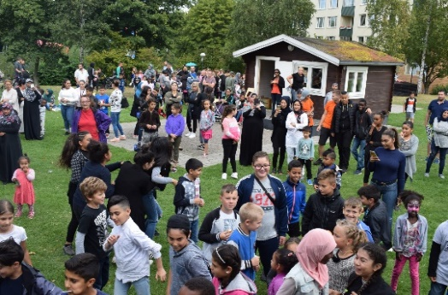

* All activities are free of charge
* Using the school as a community center
* Reaching adult residents via the children
* A potential oriented attitude
* Realise all wanted activities fast
* Promote volunteering
* Active networking with all local actors
* Common local events
* Show trust and give responsibility
* Always a bottom-up perspective

**Case study II: Neighborhood Volunteers in Debrecen region, Hungary**

**Background and objectives**

Eletfa Segitö Szolgalat Egyesulet (Lifetree Help Service Association) was founded in Csapokert district in Debrecen already 1989 and is an organization that basically is aimed at developing community work in the region. They do it by educating local residents and regional NGO´s on how to organize and coordinate community work. The basic idea of Eletfa is to foster community development out of a holistic view and out of the Settlement way of help to self-help.

Eletfa recognized that only few members of the community use local services or take part actively in the community. They got some information stating that a lot of citizens living in that area do not even know about the facilities, supports offered by the institution, many of whom even try to keep the distance from it and not wishing to recourse to professional help. This applies to all the active humanitarian organizations of Debrecen. Starting from these issues they thought that they should familiarize the ones who could supposedly benefit from the supports offered, by taking them closer to these people and to look for people to whom they can truly turn to with total confidence if any kinds of problems or questions occur. It is of primal importance that an integrated and inclusive vital local community, the network developed in the neighbourhood and the natural protective nets improves the living standard. They were interested in the ways they could actually develop on the level of the community and in the immediate neighbourhood the so called communal life, the mutual caretaking and reciprocal help giving both on the level of individuals and that of the community. They also tried to find the best ways to help mobilizing the locals in taking care of the problems that might occur in that particular suburban area of the town.

Neighbourhood Volunteers is about training volunteers who are local active citizens and key community members. Their task is to be the connection between local services, help the professional social workers to inform people and help them reach the services as well as volunteer community workers in their community.

The Neighbourhood Volunteers programme empower residents to exercise their rights as citizens through self-empowerment techniques, develop and strengthen neighbourhood relations in the district and organise a network of neighbourhood volunteers and develop volunteering and community work in the local community.

Followingly, the objectives are to:

* empower residents to exercise their rights as citizens through self-empowerment techniques.
* develop and strengthen neighbourhood relations in the district.
* organize a network of neighbourhood volunteers and develop volunteering and community work in the local community.

**Methods and activities**

It starts with information of the program to the local residents and a call for volunteers in the neighbourhood and the aim is to find informal leaders, like “trusted citizens” and interest them for the training. After receiving applications, interviews of the applicants are conducted to find the best fitted participants. The training is 36 hours long (6 hours * 6 Saturdays) and the themes are:

1. History and Purpose
2. Mapping of institutions and organisations in the district
3. Community work methods and including and democratic meeting techniques.
4. Communication and media training
5. Introduction to the structure of social services
6. Self-awareness training

After starting their work, it is needed to have ongoing needs assessment, with their participation. Volunteers work is based on need: providing information, information, assistance with administration, community organisation, mental health care, liaison with the district's institutions and supervision.

Volunteers carry out their outreach activities in their homes for two hours a week at a pre-arranged time. This is indicated on a sign in a prominent place for the residents of the street.

Supervision is monthly, by individual appointment on request and also further training and continuous updating of information.

It is important that the local community is informed about the launch of the program, both so that their needs and ideas can be integrated into the program, and so that those who want to volunteer are informed about the opportunity and how to get in touch. It is good if there is already a specific contact person to receive applications.

Neighbourhood volunteers provide a service to the public, so it makes sense to look for candidates who are accepted members of the local community, have previously participated in community events and activities, and are a voice in their own neighbourhood. Important to make interviews with the possible volunteers.

**Results/Impact/Learning**

Some practical things this led to in the districts are discussions and information in places where people meet, like in the local store, the streets, the church and gym. Information signs about how to get in contact with the Community organizers and Neighbourhood Days. A network of local community organizers is created and supervising by the Eletfa educators are offered and carried through once a month. The major impact of this program is more experienced safety, a bigger sense of community and a higher level of Active citizenship.

**Key success factors**

* Involving locally trusted persons and informal leaders in an early stage
* Mobilizing and educating residents in a well-structured way
* Using events and parties to reach and attract people
* Active networking with all local actors
* A bottom-up perspective and a holistic outlook.

**Case Study III: Outreach work – Bretagne, France**

* A targeted outreach and innovative social service delivery methods that can effectively address community needs and foster a more inclusive society.

**Background and Objectives**

The initiative "Centres Sociaux Itinérants" (Itinerant Social Centers) was launched in 2021 by the French Ministry of Solidarity and Health, aimed at bringing social services directly to the people, especially in rural areas and urban districts with policy challenges. This project is managed by the National French Federation of Settlements or Social Centers (FCSF), deploying mobile equipment such as trucks, campers, caravans, bicycles, and electric scooters across 74 areas, involving 81 social centers and other regional federations.

The primary objectives of this project are to foster social connections in public spaces, combat the digital divide through onsite digital mediators, assist with administrative processes, encourage community-driven projects, and meet residents "where they are," particularly those who are socially isolated or in precarious situations. This approach also aims at expanding the operational scope of social centers, enhancing community engagement, and innovating social outreach methodologies.

**Methods and Activities**

The project utilizes a combination of facilitation techniques, methodologies, and physical tools (e.g., caravans, bicycles) to engage directly with residents in their local environments. The strategy is based on creating safe, convivial spaces that encourage community interaction and participation.

Activities:

1. Mobile Units: Deployment of mobile social centers using vehicles equipped to reach remote or underserved areas effectively.

2. Digital Inclusion: Providing digital literacy sessions to bridge the technology gap among the community members.

3. Administrative Assistance: Offering help with administrative tasks to promote access to civic rights and services.

4. Community Projects: Facilitating and supporting resident-led initiatives by providing a platform for discussion and resource allocation.

5. Consistent Outreach: Regular visits to various locations to build trust and establish a continuous presence.

**Results/Impact/Learning**

- Enhanced social cohesion and reduced isolation among community members.

- Increased digital literacy and administrative competence among residents.

- Successful initiation and execution of various community-driven projects.

- The outreach initiatives have notably improved community trust and engagement with local social centers.

- The mobility of social services has allowed for a broader reach, especially in areas lacking fixed social service facilities.

- The importance of adaptability in outreach methods to suit different community needs.

- The effectiveness of regular and predictable outreach schedules in building community trust.

**Key Success Factors**

1. Innovative Engagement Tools: Utilizing mobile units and other physical tools effectively to reach and engage community members directly.

2. Community Involvement: Ensuring that the initiatives are community-driven, which enhances relevance and impact.

3. Regular Interaction: Maintaining consistency in outreach efforts to build long-lasting relationships.

**Case study IV: Kalliola Setlementti, Finland**

* This case study highlights the successful integration of social inclusion and active citizenship initiatives by Kalliola Setlementti, showcasing the potential of community centers as catalysts for social change and community development.

**Background and Objectives**

Kalliola Setlementti, founded in 2019, operates in Helsinki, Finland, as part of the global Settlement network originating from community-based help-to-self-help initiatives. The organization manages several community centers, a learning center with 7,500 students annually, and offers services for individuals dealing with addiction, criminal records, and employment challenges. Kalliola is dedicated to improving individual and community well-being through a wide range of services and activities.

The core mission of Kalliola Setlementti is to make life meaningful and create opportunities for good everyday life through education, employment, integration, urban culture, and inclusion. Their efforts are particularly focused on fostering social inclusion and active citizenship among immigrants, low-educated individuals, and local residents.

**Methods and Activities**

The organization's approach is strongly value-based, emphasizing trust, joy, and fairness. Kalliola Setlementti engages the community through neighborhood centers, which are crucial hubs for building trust and facilitating social interaction. These centers aim to be inclusive spaces where people from diverse backgrounds can meet, share, and develop socio-cultural initiatives.

Areas of activities:

1. Community Engagement: Utilizing neighborhood centers to host activities based on local residents' needs and wishes, such as dance, music, language training, excursions, and panel discussions.

2. Volunteer Training: Organizing training sessions for volunteers to prepare them for various roles in community engagement.

3. Green Initiatives: Maintaining a green certification for all activities, promoting recycling, and hosting discussions on environmental sustainability, particularly addressing the concerns of young people about global warming.

4.Inclusive Spaces: Setting up accessible meeting/activity spaces in convenient locations like the basements of tenant houses, with well-communicated and consistent opening hours, and providing a welcoming environment with amenities like coffee.

**Results/Impact/Learning**

* Increased community engagement and participation in the offered activities.
* Enhanced social cohesion through the integration of diverse community members.
* Development of a supportive and inclusive community environment.
* Kalliola Setlementti has effectively used its community centers to foster a sense of belonging and active citizenship among residents.
* The green initiatives have raised awareness and promoted sustainable practices within the community.
* The importance of values-driven community work in building trust and engagement.
* The effectiveness of involving residents in the planning and execution of activities to ensure relevance and sustained interest.

**Key Success Factors**

1. Community-Centric Approach: Activities and programs are designed around the needs and interests of the community members, ensuring their relevance and effectiveness.
2. Strong Value System: The organization's commitment to trust, joy, and fairness helps in building a positive and inclusive community environment.
3. Strategic Location of Facilities: Having accessible spaces in residential areas facilitates greater participation and engagement.
4. Volunteer Engagement: Well-trained and motivated volunteers are crucial in extending the reach and impact of community activities.
5. Environmental Sustainability: Integrating green values into all aspects of operation not only addresses global concerns but also resonates with the community's younger members, promoting their active participation.



**Perspectives on the Case studies**

All neighbourhood centres share some common principles regarding goals, actions and role:

* + Recognition that resources should be directed more equitably to the most disadvantaged and least powerful groups in the community who often experience the most disadvantage and discrimination.
  + A belief that local action and participation can influence local issues or concerns. Local residents are at the heart of identifying the needs of their own community and therefore are able to effectively plan and develop services which meet those needs.
  + Using the principles self-help, mutual support, community education and collective action. Being flexible, innovative and responsive to the needs of their local community.

The four case studies clearly mirrors these common approaches for doing successful local community work aimed at active citizenship and social cohesion and inclusion. They have developed successful methods to meet residents where they are, creating safe local meeting places open for all, education programs for volunteers and providing activities that are wanted/needed by the local residents. They all have a “bottom-up” perspective, a holistic outlook and have a potential oriented attitude.

All this is essential for fostering social cohesion, local identity and active citizenship.