28.10.13 / hjv

First 3-days partner meeting in Copenhagen, 4 – 6 Nov 2013
Programme and Agenda, version 3

Content
Practical information 1
Aims and key activities of the first meeting 2
Agenda of the meeting (version 3 – 28.10.2013) 3
Annexes to the agenda 4

Practical information
Time and place
Monday, 4 Nov, 1 pm – Wednesday, 6 Nov, 3 pm
At ”Grundtvigstuen”, Vartov, Farvergade 27, DK-1463 Copenhagen K
NB: just 100 meter from the City Hall at the center of the city
See www.grundtvig.dk

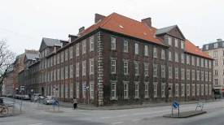 | 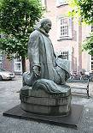 | 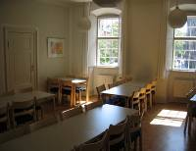
Vartov | Statue of Grundtvig | Grundtvig’s Room
Travel information
From Copenhagen Airport to the centre of the city.
- Take the metro from the airport (Terminal 3) to Nørreport Station. Then take bus nr. 11 (towards Tivoli Hotel) in front of the station (at Nørre Voldgade). Go 3 stops. Get off at Frederiksholms Kanal just beside the Nationalmuseet (look at the map!). Vartov and Hotel Danmark are just round the corner.
http://www.krak.dk/f/vartov:68124495/1463-k%C3%B8benhavn-k
OR
- Take the normal train from the airport (platform 2, Terminal 3) to the Central Station (København H), from here 10 min. walk to Vartov around Tivoli. Vartov and Hotel Denmark are just opposite the Town Hall (look at the map!).
http://www.krak.dk/f/vartov:68124495/1463-k%C3%B8benhavn-k

Tickets
Tickets for the Metro and train (3 zone ticket) are available at the Metro station and at the DSB ticket sales counter in Terminal 3. Please note that the ticket machines do not accept notes, only coins and cards such as VISA, etc.

Hotel
We will due to the social and logistic aspect recommend that all participants book a room at
Hotel Danmark, Vester Voldgade 89, 1552 København. The hotel is good, not too expensive and very near to Vartov. See http://uk.hotels.com/ho194224/hotel-danmark-copenhagen-denmark/

Meals
Monday: 01.00 pm: Sandwiches at arrival and coffee breaks at Vartov.
07.00 pm: Dinner at Les Trois Cochon
http://www.krak.dk/f/restaurant-les-trois-cochons:66118006?search_word=V%C3%A6rnedamsvej+10+1619+K%C3%B8benhavn+V

Tuesday: Breakfast at the hotel
Lunch at Vartov
Coffee breaks at Vartov
08.15 pm: Dinner at Restaurant Höst, with New-Nordic kitchen. The restaurant has just got the "Bar & Restaurant Design Award" for being the best designed restaurant in the world.
http://www.krak.dk/f/restaurant-h%C3%B6st-aps:66610147?search_word=N%C3%B8rre+Farimagsgade+41+1364+K%C3%B8benhavn+K

Wednesday: Breakfast at the hotel.
Lunch at Vartov.
Coffee breaks at Vartov.

Stakeholder and culture programme/Cultural visits
Tuesday: 01.00 – 02.30: Speech and debate, authenticity and cultural engagement, by Karen Lisa
Salamon, Associate Professor, department of Anthropology, Copenhagen University. http://anthropology.ku.dk/staff/academicstaff/?id=29267&vis=medarbejder
04.00 – 05.00 pm: Presentation, film and debate about culture guide activities in Copenhagen, by Nicolas Kragekjær Jespersen, Copenhagen culture guides, see http://www.kulturguiderne.dk/kontakt/
06.30 – 08.00 pm: History Tour in Copenhagen. You’ll hear about the role and the place and buildings in the history of Copenhagen. By Christian Holm Donatzky, historian, MA

Mobile numbers of the participants
Bente von Schindel, KSD (DK) (+45) 29 64 70 40
Hans Jørgen Vodsgaard, IF (DK) (+45) 51 300 320
Hans Noijens, LKCA (NL) (+31)-6-21 40 61 97
Jan van den Eijnden, LKCA (NL) (+31) 6 53 64 88 98 (will not participate, but may be a info helper)
Marjeta Turk, JSKD (SI) (+386) 31 817 358
Matjaz Smalc, JSKD (SI) (+386) 31 628 175.
János Szigeti Tóth, MNT (HU) (+36) 20 569 66 88
Robin Simpson VA (UK) (+44) 783 469 3819
Daniel Carpenter, VA (UK) (+44) 773 969 0762

Map of Copenhagen centre
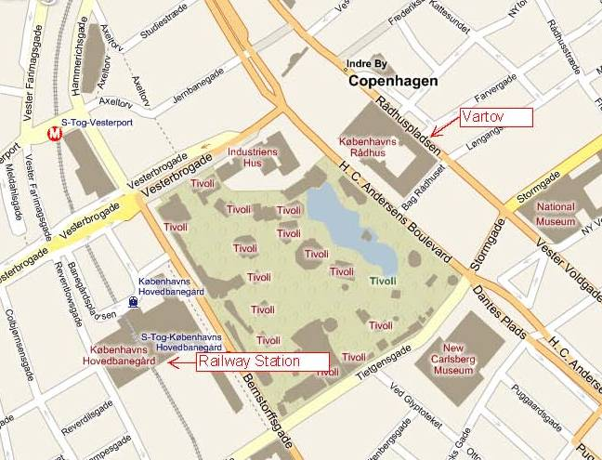

Aims and key activities of the first meeting
NB: The description is from the Project Bible
Aims and objectives:
The overall aim of this kick-off meeting is to promote performing teams with a shared ownership and high commitment and thereby bridging the way forward for the project and the partners.
The objectives are
- To consolidate a strong mutual understanding of the project concept, needs and aims
- To clarify the legal and financial conditions
- To plan the transversal tasks as integral parts of the whole work programme
- To detail plan the work programme of the next phase
- To complete a comprehensive evaluation of the start-up (WP 1 and 2)

Agenda of the meeting (version 3 – 28.10.2013)

Monday, 4 Nov, 13 – 17.30
1. Formalities
a) Appoint a moderator and a reporter
b) Approval of the agenda
c) Sign Attendance List
2a. Amendment – replacement of Latvian partner with Dutch partner
2b. Presentations:
a) Present persons, organisations and experiences with international projects
b) Present expectations to the project, personal and organisational benefits
3. The project idea and outlines of each organisation’s plans for local pilot work
a) Dialogue on the project concept – the need, the aims and core activities; Introduction by Bente
b) First dialogue on local activity plans - each organisation outlines plans for local guide activities:
Which culture offerings to end-users and where, targeting which group of social marginalised,
frame of courses for culture guide volunteers, how will other local stakeholders be involved, etc.
4. The project description, work programme and budget - present, discuss and adopt
a) Main planning tool is “Detailed description of the project” (Project Bible); introduction by Hans
b) The overall task plan including division of labour and responsibilities in the partnership
c) Clarify the time schedule - do we need more time for some tasks and less to others
d) Clarify the budget including number of project members at next meetings
Tuesday, 5 Nov, 09 – 17
5. The Conditions and demands of a Grundtvig Multilateral Project
a) The Grant Agreement with EACEA and the legal conditions
b) Experiences with EACEA as the administrators of the Grundtvig programme
6. Legal agreements - present, discuss and adopt
a) The Partner Agreement
b) Rules of procedure
7. Project management and transversal work packages - present, discuss and adopt
a) Rules of Financial management
b) Guidelines of monitoring, evaluation and QA
c) Guidelines of Dissemination
d) Guidelines of internal Communication, documentation and use of ICT
8. Project website and visual design of project materials - present, discuss and adopt
a) The visual design
b) The project website
Wednesday, 6 Nov, 09 – 15
9. Detail planning of the next steps
a) Second dialogue on local activity plans – each organisation summaries their initial plans
b) Clarify the goals and tasks of WP 03: Initiate local pilot works, Nov 2013 – Feb 2014
c) Adopt a detail time schedule of WP 03
d) Clarify transversal tasks – evaluation & QA as well as dissemination
e) Decide time and place of the second 3-days partner meeting in London, Feb 2014
10. Evaluation of the previous work
a) Summary of evaluation questionnaires of WP 01: Start-up planning
a) Oral evaluation round on WP 01: Start-up planning
b) Oral evaluation round of WP 02. The first partner meeting
c) Fill-out the meeting evaluation questionnaire (latest 1 week after the meeting)
10. A.O.B. (any other business)

Annexes to the agenda
- All annexes were e-mailed 19.08.2013, and again unchanged 17.09.2013. They can also be downloaded at our virtual project archive at the Google site - https://sites.google.com/site/gmpcultureguide/
Item 1: Formalities
c) GUIDE – WP 02, first meeting, agenda, version 3
d) GUIDE - Template finance, meeting attendance List, version 1
Item 2a. Amendment – change of partner (from Latvian to Dutch)
The amendment request
Annex a: Signed request by coordinator
Annex b: Letter from Latvian partner with reasons for withdrawal
Annex c: the mandate letter, signed by LKCA and KSD
The project description, version 3 (the new Project Bible)
The internal project budget, version 3
The official Grundtvig budget form, version 3
Item 2b: Presentations (tasks referring to WP 2)
Grundtvig MP_DK_GUIDE_BIBLE, version2, Aug 2013, page 3 – 14 presents organisations and persons.
NB: Not necessary to make one more written presentation; however, all are very welcome to bring extra presentations (power points, videos, hand-outs, etc
Item 3: The project concept and initial local project plans
a) Grundtvig MP_DK_GUIDE_BIBLE, version3, Oct 2013, page 15 – 21 presents project characteristics
b) The local pilot work is primarily described in Work package 3, 5 and 6 – see “the project Bible”,
page 40 – 46, 52 -60, and 61 – 67 to get ideas for your plans for local pilot work.
Item 4: The project description, work programme and budget
a) GUIDE - the project BIBLE, version 3, Oct 2013 includes all the detailed plans and budgets
b-c) Guide – outline of task plan and time table, version 1
d) GUIDE - internal WP-budget, version 3, Oct 2013
Item 5 – 8: Transverse appendices (filled-out questionnaire for start-up planning) (deadline 28 Oct)
GUIDE - WP1, questionnaire for start-up, P1: KSD
GUIDE - WP1, questionnaire for start-up, P2: IF
GUIDE - WP1, questionnaire for start-up, P3: LOH
GUIDE - WP1, questionnaire for start-up, P4: JSKD
GUIDE - WP1, questionnaire for start-up, P5: MNT
GUIDE - WP1, questionnaire for start-up, P6: VA
Item 5: Conditions and demands for a Grundtvig Multilateral Project
a) The Grant Agreement with EACEA (Mailed 22.09.2013)
The LLL- Handbook 2013, EN (haven’t been published yet)
The Guidance Notes on Audit.
Item 6: Legal agreements
a) GUIDE - Documents for effective PM - Partner Agreement, version 2
b) GUIDE - Documents for effective PM - Rules of procedure, version 2
Item 7: Project management
a) GUIDE - Documents for effective PM – Rules of Financial management, version 2
GUIDE – Template finance, information of partners bank account, version 1
GUIDE - Template finance1, refunding of work task, version 1
GUIDE - Template finance1a, job log, version 1
GUIDE - Template finance2, refunding of travel and subsistence, version 1
GUIDE - Template finance2a, host costs for partner meetings, version 1
GUIDE - Template finance3, refunding of other costs or subcontractor, version 1
b) GUIDE - Documents for effective PM – Guidelines of evaluation and QA, version 1
GUIDE - Template QA, WP1 - questionnaire for start-up, version 1
GUIDE - Template QA, WP1 - process evaluation of start-up tasks, version 1
GUIDE - Template QA, WP2 - evaluation of first meeting in Copenhagen, version 1
GUIDE - Template QA, WP3 - process evaluation of local pilot work, version 1
c) GUIDE - Documents for effective PM – Guidelines of Valorisation, version 1
GUIDE - valorisation - essentials of a valorisation plan, version 1
GUIDE - Target groups, Transbaltic, Transeuropean and Global, version 1, by P2, IF
GUIDE - Target groups, Nordic-Baltic region, version 1, by P2, IF
GUIDE - Target groups, Europe ex Nordic-Baltic region, version 1, by P2, IF
d) GUIDE - Documents for effective PM – Guidelines of internal communication, version 1
LOGO - EU_flag_LLP_EN-01
GUIDE - Template communication, Letter Heading 2
Item 8: Visual design and project website
a) Proposal for visual design, version 1 by Voluntary Arts (UK) will follow
b) Proposal for project website, version 1 Voluntary Arts (UK) will follow
Item 9: Detail planning of the next steps
b-c) GUIDE - the project BIBLE, version 3, page 40 – 47 (Description of WP 03)
d) GUIDE - the project BIBLE, version 3, page 107 – 125 (Description of WP 14, 15 and 16)
Item 10: Evaluation of the previous work
a) GUIDE - WP1, process evaluation of start-up, P1: KSD
GUIDE - WP1, process evaluation of start-up, P2: IF
GUIDE - WP1, process evaluation of start-up, P3: LOH
GUIDE - WP1, process evaluation of start-up, P4: JSKD
GUIDE - WP1, process evaluation of start-up, P5: MNT
GUIDE - WP1, process evaluation of start-up, P6: VA

c) GUIDE - Template QA, WP 2 - Evaluation of first meeting, version 1
(to be filled-out latest 1 week after the first meeting)

