|  |
| --- |
| ***Initiate successful European cooperation***  **in the civil society sector of adult education**  **Two parallel 2-day pilot courses**  **29th of February and 1st of March 2020**  **in Vartov, Copenhagen** |

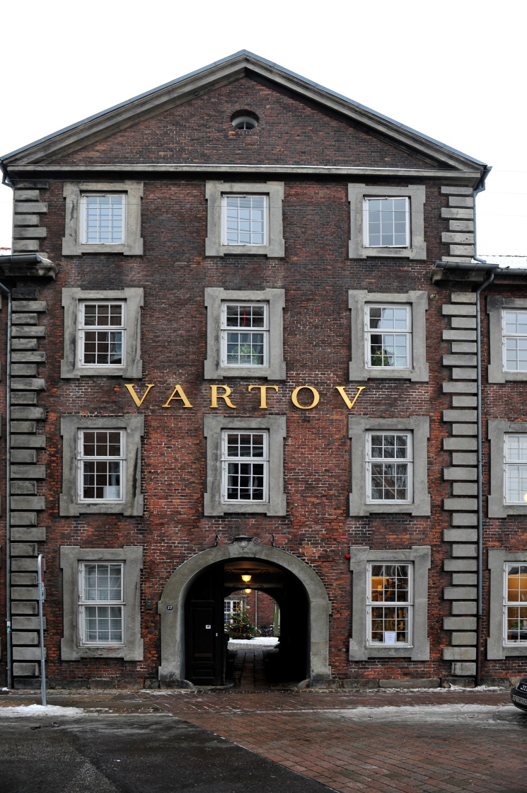

**© 2019: Interfolk**

**Programme, v2, 21.02.2020**

**This programme version may be subject to minor changes without notice**

***Content***

1. The frame 3

Course titles 3

Time and place 3

Part of an Erasmus+ project 3

Vartov – a historical place 3

2. Target audience 4

Target groups 4

Number of participants 4

Special needs 4

3. Key features 4

Type of events 4

Learning aim 4

Learning outcome 4

Teaching methodology 5

Course materials and preparation 5

Certificate of Attendance 5

Evaluative follow-up 5

4. The day-to-day programme: 29th of Feb – 1st of March 2020 6

Saturday, 29th of Feb: 6

Sunday, 1st of March: 7

5. Course fee and enrolment 8

No course fee 8

Enrolment 8

6. Course providers / contact information 8

Course provider 8

Course leaders and teachers 8

This Danish pilot course has been developed in the framework of the 2-year Erasmus+ development project, Sept 2018 – Aug 2020, entitled: : “First-time international project realisers support network”

For more information, see the project portal: <https://first-network.eu/en>

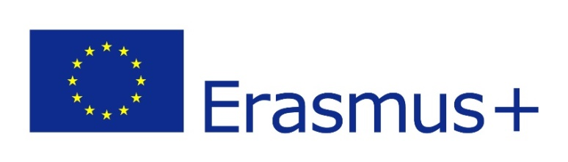

The project is co-funded by the Erasmus+ Programme of the European Union

The course programme reflects the views only of the authors, and neither the Polish National Agency of the Erasmus+ programme nor the European Commission can be held responsible for any use which may be made of the information contained therein.

# 1. The frame

## Course titles

***Course A: For project managers - initiate successful European cooperation in the civil society sector of adult education***

***Course B: For members of management bodies - initiate successful European cooperation in the civil society sector of adult education***

## Time and place

The two courses take place Saturday, 29.02.2020, 10:00 - 16:00 and Sunday, 01.03.2020, 10:00 - 16:00

at Vartov, Farvergade 27 D, 2nd, DK-1463 Copenhagen K

NB: just 100 meter from the City Hall at the center of the city

See [www.grundtvig.dk](http://www.grundtvig.dk) and <http://map.krak.dk/?index=yp&id=68124495&query>=

## Part of an Erasmus+ project

The course is part of the 24-months development project, Sept 2018 – Aug 2020, entitled: “First-time international project realisers support network”.

The course is thereby co-funded by the Erasmus+ Programme of the European Union.

## Vartov – a historical place

[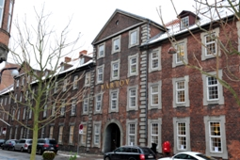](http://da.wikipedia.org/wiki/Fil:Vartov_01_2006.jpg) [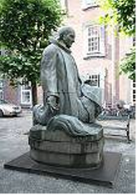](http://da.wikipedia.org/wiki/Fil:Grundtvig_Vartov_Copenhagen_2.jpg) 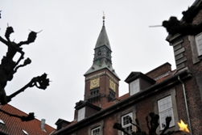

|  |  |  |
| --- | --- | --- |
| Entrance to Vartov | Statue of Grundtvig | City Hall tower seen from Vartov’s courtyard |

Vartov is an historic and beautiful building with Copenhagen City Hall as its closest neighbour.

Vartov is known to have had the famous Danish poet, priest and adult educator N.F.S. Grundtvig as pastor in 33 years from 1839 to 1872 at the Vartov church which is part of the building complex.

In 1947 the Danish Grundtvig Society took over Vartov. The building underwent an extensive restoration and was particularly adapted for their new purpose, which was a continuation of the Grundtvigian youth and educational work.

Today the Grundtvig library and the Grundtvig Academy as well as many educational and cultural umbrella associations have addresses here.

# 2. Target audience

## Target groups

For course A: Project managers and for course B: Members of management bodies, where both groups

* come from civil society organisations active in the field of non-formal adult education and informal lifelong learning,
* which can be seen as beginners or inexperienced with international cooperation (it means have max participated in one international funded project or mobility activity).

## Number of participants

min 8 – max 12 trainees per course, in all 16 – 24 trainees.

## Special needs

The course venue has wheelchair lifts.

In case of allergy or other special needs, please tell the course leaders at the enrolment.

# 3. Key features

## Type of events

Two non-residential 2-day pilot courses, with a volume of 16 academic hours (45 min), like 12 hours ex breaks. It includes:

* 6 academic class-room hours: Saturday, 10 – 16 (including coffee breaks and lunch)
* 6 academic class-room hours: Sunday, 10 – 16 (including coffee breaks and lunch)
* 4 academic homework hours: Before and after.
* Before: 3 academic hours to have a dialogue in the organisation and fill-in the query about European development plan and project ideas as part of the recruitment demands.
* After: 1 academic hour for assessment of learning outcome and course evaluation.

## Learning aim

Course A: The project managers should at the end of the training have gained some real knowledge and skills at planning, developing and realising international project.

Course B: The management bodies should at the end be able to make a conscious decision: if the organization is “ready” to undertake international cooperation, and if not – what is still needed to get prepared.

## Learning outcome

We presume that the planned learning outcomes for the two groups can be the same, even though they will use the outcomes with different focusses.

We also presume that the number of learning outcome and thereby topics of the course must be quite limited for a 2-day course with just 12 academic class-room hours. Therefore, we have chosen to focus on the first step of the international cooperation, i.e. to prepare successful applications to the Erasmus+ programme; and here we have chosen the following 4 main learning outcomes:

1. More knowledge of the funding programmes with focus on Erasmus+ including:

* The Erasmus+ mobility courses and study visits (KA1)
* The Erasmus+ strategic partnership projects (KA2)

1. More knowledge and skills to prepare successful Erasmus+ project applications, including:

* To develop the project concept (project idea) with focus on needs and aims
* To clarify the key activities and main outputs
* To plan the dissemination, evaluation, and management.
* To prepare the work programme and budget
* To find partners as coordinator or promoting oneself as a partner,

1. More knowledge and skills to prepare successful Erasmus+ mobility applications, including:

* Preliminary to clarify/develop the international development plan of one’s own organisation
* To develop the mobility concept with focus on learning needs and aims
* To clarify if the priorities is to enrol to training courses or plan more open study visits
* To plan the mobility programme and budget
* To find hosting partners

1. More know-how to self-assessment and needs for competence development to work with international cooperation, including

* To clarify/develop the international development plan of one’s own organisation
* To assess own needs for competence development to work with international cooperation.
* To transfer the learned to the situation at home after the course

## Teaching methodology

The teaching should be based on participatory and activity-based methods, integrating theory and shared experience, as well as the transferability of the learning into the specific tasks in the specific organization. It will include a blend of

* Short concise lectures, plenary discussions, workshops and peer-to-peer assessments.
* Individual homework before the course to provide need assessments and organisational motivation and after the course to assess the learning outcome (competence increase)

## Course materials and preparation

* As background material for home study the two baseline reports (IO1 & IO2)
* The Erasmus+ programme guide 2020
* The programme information at the Danish national office about the Erasmus+ programme
* The information at the project portal (if it has been published)
* The varied development plans provided by the trainees in the pre-course query

## Certificate of Attendance

Participants will get a Certificate of Attendance stating the frame, content, method and the working hours of the course.

## Evaluative follow-up

For the evaluative follow-up, each trainee fill-in:

* A query for course evaluation
* A query for self-assessment of the learning outcome including competence increase

# 4. The day-to-day programme: 29th of Feb – 1st of March 2020

|  |
| --- |
|  |
|  |

## Saturday, 29th of Feb:

*09:30 – 10:00 Course registration and morning coffee, croissants and fruits*

10:00 - 10:15 Welcome and presentation of programme and participants

10:15 – 11:00 Presentation of main funding programmes

By Bente von Schindel

*11:00 – 11.15 Coffee break*

11.15 – 11:45 Introduction to international development plans and project ideas

By Hans Jørgen Vodsgaard

11:45 – 12.30 1st group session about international development plans and project ideas

Group A: Project managers – Moderator: Hans Jørgen Vodsgaard

Group B: Members of man. bodies – Moderator: Bente von Schindel

*12:30 – 13.00 Lunch at Vartov*

13:00 – 13:30 Introduction to prepare successful applications for development project

By Hans Jørgen Vodsgaard

13:30 – 14.10 2nd group session about international development plans and project ideas

Group A: Project managers – Moderator: Bente von Schindel

Group B: Members of man. bodies – Moderator: Hans Jørgen Vodsgaard

*14:10 – 14.40 Coffee break*

14:40 – 15:10 Introduction to prepare successful applications for mobility activities

By Hans Jørgen Vodsgaard

15:10 – 15:55 3rd group session about international development plans and project ideas

Group A: Project managers – Moderator: Hans Jørgen Vodsgaard

Group B: Members of man. bodies – Moderator: Bente von Schindel

15:55 – 16:00 Conclusion and outline of programme next day

## Sunday, 1st of March:

*09:30 – 10:00 Course registration and morning coffee, croissants and fruits*

10:00 - 10:15 Summary of presentations and outcome of workshops.

By Bente von Schindel and participants

10:15 – 10:45 How to find project partners or promote oneself as partner.

Presentation by Bente von Schindel

10:45 – 11:30 Planning of work programme and budget for cooperation projects.

Presentation by Hans Jørgen Vodsgaard

*11:30 – 11.45 Coffee break*

11.45 – 12:30 Planning of work programme and budget for mobility activities.

Presentation by Hans Jørgen Vodsgaard

*12:30 – 13.00 Lunch at Vartov*

13:00 – 13.45 4th group session about planning of work programme and budget

Group A: Planning Cooperation projects – Moderator: Bente von Schindel

Group B: Planning Mobility Activities – Moderator: Hans Jørgen Vodsgaard

13:45 – 14:00 Transfer the learned to work at home – outline the next steps

Introduction by Hans Jørgen Vodsgaard

14:00 – 14:45 5th group session about transference of the learned

Group A: Project managers – Moderator: Hans Jørgen Vodsgaard

Group B: Members of man. bodies – Moderator: Bente von Schindel

*14:45 – 15.00 Coffee break*

15:00 – 15:20 Peer-to-peer assessment of own learning profile and future learning needs

15:20 - 15:40 Plenary session about course evaluation

* Oral course evaluation by trainees and trainers
* Introduction of evaluative follow-up: Query for self-assessment of learning

outcome and query for course evaluation

Moderator: Bente von Schindel / reporter: Hans Jørgen Vodsgaard

15:40 – 15:55 Plenary Ceremony with Course Certificate of attendance

15:55 – 16:00  Farewell

# 5. Course fee and enrolment

## No course fee

There is no course fee.

The main costs of the courses including rent of course venue, fees for trainers, administration, course materials and coffee breaks and two lunches are co-funded by the Erasmus+ programme.

The participants must cover their own travel costs and possible accommodation in Copenhagen.

## Enrolment

Interested participants must enrol by filling-in and emailing the registration form to Interfolk.

The registration form is an annex to this course programme.

# 6. Course providers / contact information

## Course provider

The course provider is Interfolk – Institute for Civil Society that is partner in the Erasmus+ development project.

For more information about the Erasmus+ project, see: <https://first-network.eu/en>

For more information about Interfolk, see: [www.interfolk.dk](http://www.interfolk.dk)

## Course leaders and teachers

Hans Jørgen Vodsgaard, chief executive, Interfolk – Institute for Civil Society; cand. phil. and mag. art (History of ideas): (+45) 51 300 320 * [hjv@interfolk.dk](mailto:hjv@interfolk.dk)

Bente von Schindel, secretary general, National Association of Cultural Councils in Denmark; MA (Danish literature and rhetoric): (+45) 29 64 70 40 * [bs@kulturellesamraad.dk](mailto:bs@kulturellesamraad.dk)

You are always welcome to contact us for further information or advice regarding your possible participation in the Course.