AW and HJV

15.05.2019

**WP 14: Fourth 2-day partner meeting in Vienna, 22 – 23 May 2019**

***Programme and Agenda, version 2***

*Content*

Time and place 1

Practical information 1

Mobile numbers of the participants 4

Aims and key activities of the fourth meeting 4

Agenda of the meeting, v1 5

## Time and place

**Time:** Wednesday, 22 May, 9:30 – Thursday, 23 May 2019, 13:00

**Place:** Museumsplatz 1, 1070 Wien, main building 3rd floor

See <https://goo.gl/maps/VrSfajowgJK2>



Spread over 90,000m2 in central Vienna and encompassing 60 cultural institutions, the Museums-Quartier Wien is one of the largest districts for contemporary art and culture in the world. Nothing is off limits at the MuseumsQuartier. Historic architecture meets contemporary design. High culture meets subcultures. The spectrum ranges from fine art, architecture, music, fashion, theatre, dance, literature, children’s culture, game culture, and street art to design and photography.

## Practical information

**Refunding of costs & needed documentation**

The gross unit support is 575 euro for one foreign participant per organisation. This amount will be refunded (minus each partner’s share of the host cost for coffee breaks, two lunches and one dinner, possible cultural feature, etc.) independently of how many nights and days you stay and the level of cost of hotels and meals.

Therefore, we plan for a short meeting and low-cost meals and cultural features, so you can get your meetings costs covered for one participant and maybe still get a surplus to your organisation. You are of course welcome to stay more days or to bring more participants, but you will still only get one gross unit support of 575 euro per organisation (minus your part of the shared host costs for meals, tour guide, etc).

The needed documentation for your participation is a signed attendance list from the start of the meeting as well as a copy of your travel ticket/boarding card to confirm your place of departure.

**Hotel**

For accommodation, we recommend one of the following hotels. For sure, you are free to choose others, as there are many fine hotels in Vienna. We just chose the ones around the venue, which are affordable and nice.

Near the MuseumQuarter (5 min walk to the venue)

Viennart – Hotel am Museumsquartier Vienna

Breite Gasse 9

<https://austrotel.at/hotel-viennart/en/>

Hotel Savoy Garni

Lindengasse 12

<https://www.hotelsavoy.at/en/>

A bit more expensive:

K+K Hotel Maria Theresia

Kirchberggasse 6

<https://www.kkhotels.com/en/vienna/hotel-maria-theresia>

Haydn Hotel  
Mariahilfer Straße 57-59  
<https://www.haydn-hotel.at/>

Near the City Hall (10 min walk to the venue)  
Residenz  
Ebendorferstraße 10  
<https://residenz.com/>

Hotel Alpha  
Buchfeldgasse 8  
<https://www.hotelalpha.at/hotel-alpha/index.html>

Near the Opera/Karlsplatz (10 min walk to the venue)  
Carlton Opera Hotel  
Schikanedergasse 4  
<http://www.carlton.at/>  
  
Motel One Staatsoper  
Elisabethstraße 5  
<https://www.motel-one.com/de/hotels/wien/hotel-wien-staatsoper/>

It is up to each Partner, if you wish to book one of these hotels, or would rather find another one at [www.booking.com](http://www.booking.com) or [www.hotel.com](http://www.hotel.com) or any other portal.

**Travel information**

From the airport you take the S7 (in direction to Floridsdorf) to the station “Landstraße /Wien Mitte”.

Then take the U3 (in direction to Ottakring) and get off at the station “Volkstheater” (exit Burggasse).

The metro station is just at the north west corner of the MuseumsQuartier. Go to the middle of the complex and to the main entrance (see the mark at the map below). There is the MQ Point (a little shop for merchandising etc.). Near the MQ Point you can find an elevator.

Please step into the elevator and call +43-1-522-3127, and people at EDUCULT will fetch you up to the 3rd floor (if you not have stepped into the elevator, when you call and talk with the EDUCULT staff, you risk the elevator will go up without you!).

**Meals**

Tuesday: 21 May: If you arrive Tuesday, the day before the meeting starts, you can have a dinner anywhere at the many cosy restaurants in the city centre.

Wednesday: 22 May: Breakfast at the hotel or during your travel. We arrange coffee breaks at the venue and lunch and dinner near the venue/in the town.

Thursday: 23 May: Breakfast at the hotel. We arrange coffee breaks at the venue and lunch near the venue.

**Culture programme/Cultural visits**

The many restaurants in and around the MuseumsQuartier will be fine for the lunches a well as for the dinner.

The meeting is short and we have many issues to discuss; however, we plan to have a cultural visit at the first day, Wednesday 22 May, after our meeting.

If you wish, you are also welcome to arrive earlier and take part in the conference about culture and education policies at Tuesday, 21 May: <http://educult.at/en/veranstaltungen/cultural-policy-and-shaping-the-future-cultural-and-educational-policy-two-sides-of-the-medal/>

**Your luggage the second day after check-out at the hotel**

If you wish, you can bring your luggage to the meeting venue, Thursday morning and you can keep it here and get it after the meeting ends.

**Detail of Vienna, where the meeting venue is marked**

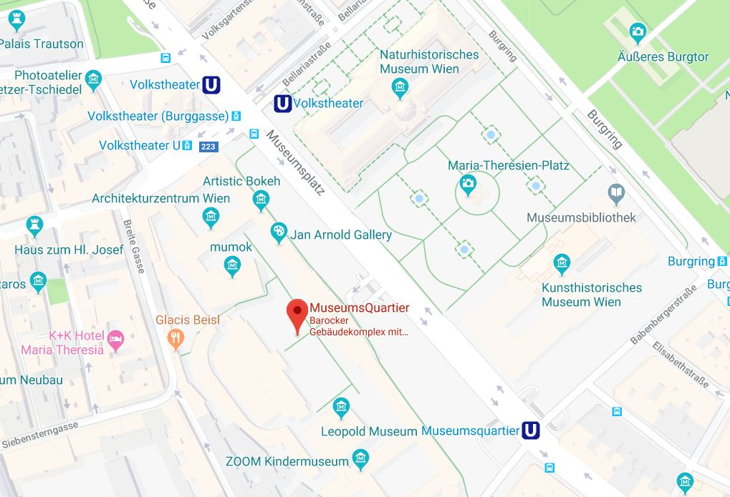

## Mobile numbers of the participants

Aron Weigl, EDUCULT (AT) (+43) 660 8421413

(+43) 1 5223127 20

Bente von Schindel, KSD (DK) (+45) 29 64 70 40

Hans Jørgen Vodsgaard, Interfolk (DK) (+45) 51 300 320

Damien McGlynn, VAN (UK) (+44) 781 802 8128

Agnieszka Dadak, FAIE (PL) (+48) 511 551 439

Rafał Dadak, FAIE (PL) (+48) 881 676 468

Jerzy Kraus, FAIE (PL) (+48) 515 249 819

Aira Andriksone, LACM (LT) (+371 26 52 41 93

Jan Pirnat, JSKD (SI) (+386) 31 381 238

Marjeta Turk, JSKD (SI) (+386) 31 817 358

Hans Noijens, LKCA (NL) (+31) 62 14 06 197

Ingrid Smit, LKCA (NL) (+31) 61 13 52 495

## **Aims and key activities of the fourth meeting**

The overall aim of this fourth and concluding meeting is to evaluate the project and plan possible follow-up activities.

The key points of the meeting are:

* To evaluate the provision of the translated five Thematic Compendia (IO-3). P3, VAN
* To evaluate the completion of last national pilot courses (IO-5). P7, JSKD
* To evaluate the Curricula Guidelines, seven languages ed (IO-7). P2, IF
* To Design and promote Erasmus+ courses – cancelled (IO-8)
* To evaluate the completed seven national multiplier events / conferences (E1-E7). P4, FAIE
* To evaluate the Communication Portal and plan possible refinements and prolonging after end of project (IO-1). P8, LKCA
* To plan the last output, the Project Summary Report (IO-9). P1, KSD
* To evaluate the current and schedule the remaining dissemination activities. P3, VAN
* To evaluate the current and schedule the remaining progress and impact evaluation. P5, EC
* To evaluate the current and schedule the remaining project management, including

the needed project documentation as well as project reporting in the Mobility+ Tool. P2, IF

* To plan possible follow-up activities
* To have an over all evaluation of the project
* To evaluate the fourth partner meeting

## Agenda of the meeting, v1

**Wednesday, 22 May, 9:30 – 16:00**

1. Formalities

a) Welcome and practical information

b) Appoint a moderator and a reporter

c) Approval of the agenda

d) Sign Attendance List

2. Evaluate the provision of the translated five Thematic Compendia (IO-3). P3, VAN

3. Evaluate the completion of last national pilot courses (IO-5). P7, JSKD

4. Evaluate the Curricula Guidelines, seven languages ed (IO-7). P2, IF

5. Evaluate the completed seven national multiplier events / conferences (E1-E7). P4, FAIE

6. Evaluate the Communication Portal and plan possible refinements and prolonging (IO-1). P8, LKCA

7. Plan the last output, the Project Summary Report (IO-9). P1, KSD

8. Evaluate the current and schedule the remaining dissemination activities. P3, VAN

9. Evaluate the current and schedule the remaining progress and impact evaluation. P5, EC

**Thursday, 23 May, 9:30 – 13:00**

10. Evaluate and schedule remaining project management, including financial management. P2, IF

11. Plan possible follow-up activities. All

12. Plan possible Final Skype meetings in the last period, May – Aug 2019

13. To have an overall evaluation of the project

14. To evaluate the fourth partner meeting

15. A.O.B. (any other business)

To find documents, see

[The Google archive for initial documents](https://sites.google.com/site/bridgingsocialcapital/)

[The Goggle archive for work plan documents](https://sites.google.com/site/bridgingworkplan/home)

And

[extra Google drive for the Thematic Compendia](https://drive.google.com/drive/folders/12s5R51XG68SfgG_p4s2xJfEAbIiQBASU)