AA and HJV
20.11.2018

Third partner meeting in Riga, 26 – 27 November 2018
Programme and agenda, version 2

Content
Time and place 1
Practical information 1
Mobile numbers of the participants 3
Aims and key activities of the third meeting 3
Agenda of the meeting (version 1 – 22.10.2018) 4

Time and place
Time: Monday, 26th Nov, 10:30 – Tuesday, 27th Nov, 15:00 pm
With possible arrival Sunday 25th Nov with two nights: Sunday- Monday, Monday – Tuesday,
and a possible departure, Tuesday evening
Place: EU House, 2nd floor, Aspazijas bulvaris 28, Riga
Info about EU house - see http://esmaja.lv
Find place – see google map
The place is just some 100 meters from the City Centre at the House of the Blackheads and the main Tourist Information Centre. See the House of the Blackheads here

Practical information
Refunding of costs
The gross unit support is 575 euro for one foreign participant per organisation. This amount will be refunded (minus each partner’s share of the cost for common meals, rent of venue, etc.).
We have planned a short meeting and low-cost meals and cultural features, so you in fact can get your meetings costs covered for one participant. You are of cause welcome to stay more days or to bring more participants, but you or your organisation must pay the extra cost.
The needed documentation for your participation is the signed attendance list as well as a copy of your travel ticket/boarding card to confirm your place of departure.

Hotel
For accommodation, we recommend you to find appropriate hotels in the centre of the city.
You can use www.hotel.com or the like.

Travel information
You can get to the city centre from Riga International Airport by Bus No 22 and Minibuses No. 322 or 241 and it takes ~ 20-25 min depending on traffic:
http://www.riga-airport.com/en/main/passengers/useful-information/getting-to-from-the-airport
Information about public transport tickets & prices in Riga:
https://www.rigassatiksme.lv/en/tickets-and-e-ticket/types-and-prices-of-tickets-1/

For using taxi service from/to airport or within the city please follow the information and recommendations both by airport and Riga Tourism Development Bureau (LiveRīga):
http://www.riga-airport.com/en/main/passengers/useful-information/getting-to-from-the-airport/taxi-service
https://www.liveriga.com/en/21-taxi
Official Riga Tourist Information:
https://www.liveriga.com/en/

Meals
Monday: 26 Nov: Breakfast at the hotel. We arrange coffee breaks at the venue and lunch 12.30 – 13.15 and dinner in the city centre, 20:00 – 21:30.
Tuesday: 27 Nov: Breakfast at the hotel. We arrange coffee breaks at the venue and lunch 12:00 – 12.45.
Culture programme/Cultural visits
The meeting is short and we have many issues to discuss, however there should be time for a 1,5 hour Walking Tour in the Old City, 18:15 – 19:45. Hereby you have time after the end of the meeting the first day, 17:00 to come back to your hotel before the Walking Tour and the dinner.
Your luggage the second day after check-out at the hotel
You can bring your luggage to the meeting venue or pick it up at the hotel after the end of the meeting, latest 15:00.
Map of Riga centre
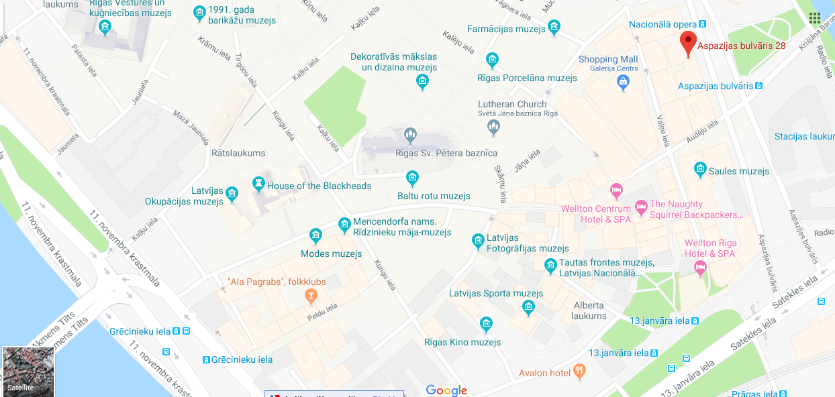

Mobile numbers of the participants
Aira Andriksone, LACM (LT) (+371 26 52 41 93
Bente von Schindel, KSD (DK) (+45) 29 64 70 40
Hans Jørgen Vodsgaard, Interfolk (DK) (+45) 51 300 320
Damien McGlynn, VAN (UK) (+44) 781 802 8128
Rafał Dadak, FAIE (PL) (+48) 881 676 468
Jerzy Kraus, FAIE (PL) (+48) 515 249 819
Aron Weigl, EDUCULT (AT) (+43) 660 8421413
Jan Pirnat, JSKD (SI) (+386) 31 381 238
Hans Noijens, LKCA (NL) (+31) 62 14 06 197
Ingrid Smit, LKCA (NL) (+31) 61 13 52 495

Aims and key activities of the third meeting
The overall aim of this second meeting is to summarize the state of the project and lead the way forward for the project and for the partners, including
- to bridge the results of the survey (WP 04/IO-2) to the succeeding compilation of good practise in thematic fields of bridging (WP 06 /IO-3), the provision of Curricula Guidelines (WP 07/IO-4) and the design and test of the national pilot courses (WP 08/IO-5).
The key points of the meeting are:
- To evaluate the provision of the five Thematic Compendia (IO-3)
- To evaluate the provision of the Curricula Guidelines (IO-4)
- To evaluate the national pilot courses (IO-5)
- To provide two European Pilot courses (IO-6) was cancelled by the Danish NA
- To outline and schedule the provision of the Curriculum Report, seven language ed. (IO-7)
- To design sustainable Erasmus+ course packages (IO-8) was cancelled by the Danish NA
- To frame and schedule the seven national conferences (E1-E7)
- To assess and schedule deliverances to the Communication Portal (IO-1)
- To evaluate the current and schedule the remaining dissemination activities
- To evaluate the current and schedule the remaining progress and impact evaluation
- To evaluate the current and schedule the remaining project management, including
the needed project documentation as well as project reporting in the Mobility+ Tool
- To decide time and place of final fourth partner meeting
- To evaluate the third partner meeting

Agenda of the meeting (version 2 – 23.11.2018)

1. Formalities
a) Welcome and practical information
b) Appoint a moderator and a reporter
c) Approval of the agenda
d) Sign Attendance List, first day

2. Evaluate and plan O3: Five Thematic Compendia
a) Status of work
- Status of 1st compendia: Inter-social bridging - by editor Damien, VAN
- Status of 2nd compendia: Inter-generational - by editor Jan, JSKD
- Status of 3rd compendia: Inter-regional - by editor Bente, KSD
- Status of 4th compendia: Inter-cultural - by editor Hans, LKCA
- Status of 5th compendia: Inter-European - by editor Agnieszka, FAIE
b) Overall status and evaluation of the work
c) Possible remaining time schedule: Who does what and when?

3. Evaluate and plan O4: Curricula Guidelines
a) Status of work, by editor, Hans, Interfolk
b) Evaluation of the work
c) Possible remaining time schedule: Who does what and when?

4. Evaluate and plan O5: National pilot courses
a) Status of work
- Status of Danish pilot course – by Bente, KSD
- Status of British pilot course – by Damien, VAN
- Status of Polish pilot course – by Agnieszka, FAIE
- Status of Austrian pilot course – by Aron, Educult
- Status of Latvian pilot course – by Aira, LACM
- Status of Slovenian pilot course – by Jan, JSKD
- Status of Dutch pilot course – by Hans, LKCA
b) Overall status and evaluation of the work
c) Possible remaining time schedule: Who does what and when?
d) Lessons learned and recommendations for the Curricula report, by Aron, Educult

5. Plan the Curriculum Report, seven language ed. (IO-7)
a) Outline of planned content and key tasks, by editor, Hans, Interfolk
b) Clarify guidelines for the structure and content
c) Plan time schedule: Who does what and when?

6. Assess and schedule O1: Communication Portal (IO-1)
a) Status of decided work for the side menus
1) Overview of trends in the EU supported projects, by Ingrid, LKCA
2) Communication /news-mails etc to European targets, by Hans, LKCA
3) Facebook interaction, by Ingrid, LKCA and Jan, JSKD
4) Overview of culture policies – In EU states, in Nordic region, in the EU Commission,
articles by Aron and Hans and presentation at website by Hans, LKCA

5) Overview of relevant European training events, feeds by Aira, LACM and Hans, Interfolk
and presentation at website by Ingrid, LKCA
6) Overview of relevant funding programmes, by Agnieszka, FAIE and Hans, Interfolk,
and presentation at website by Ingrid, LKCA
7) Intro to and uploads of survey, seven editions, by Hans, LKCA
8) Intro to and uploads of Curricula Guidelines, by Hans, LKCA
9) Intro to and materials from the pilot courses and presentation at website
10) Intro to and presentation of the partner meetings?
11) Other possible deliverances?
b) Status of decided work for the main top menu
1) Status of the presentation of the five thematic fields – by Hans, LKCA
2) Dialogue and advices for the structure and content of the presentations
c) Overall status and evaluation of the portal work
d) Plan time schedule: Who does what and when

7. Plan the seven national conferences (E1-E7)
a) Outline of programme frame, by lead partner, Agnieszka, FAIE
b) Clarify guidelines for frame and content
c) Plan time schedule: Who does what and when?

8. Assess and plan the dissemination activities
b) Status of dissemination until now; May – Aug 2018 – by Damien, VAN
c) Plans for the remaining dissemination
d) Plan time schedule: Who does what and when?

9. Assess and plan the evaluation activities
a) Status of the progress evaluation until now, by Aron, Educult
b) Plan time schedule for the progress evaluation: Who does what and when?
c) Plans for the impact evaluation with reference to decision at 2nd meting – by Aron, Educult
c) Plan time schedule for the impact evaluation: Who does what and when?

10. Assess and plan the project management activities
a) Status of the management activities incl. documentation demands, by Hans, Interfolk
b) Reporting in Mobility tool and the project results Platform
c) Plan time schedule: Who does what and when?

11. Plan the fourth partner meeting and possible Skype meetings
a) Fourth meeting planned to take place, May 2019 in Vienna.
Decide time frame. Proposals by the host, Aron, Educult
b) Need for Skype partner meetings until fourth meeting? If so, what and when?

12. Evaluation of this third partner meeting
a) Oral evaluation round – moderated by Aron, Educult
b) Summary of evaluation round, by Aron

13. A.O.B. (any other business)

