06.04.2018 / hjv

Agenda, v2
Second partner meeting in Bielsko-Biala, 9 – 10 April 2018

Content
Time and place 1
Practical information 1
Mobile numbers of the participants 3
Aims and key activities of the first meeting 3
Agenda of the meeting (version 1 – 4.4.2018) 4
Annexes to the agenda 6

Time and place
Time: Monday, 9th April, 10:00 am – Tuesday, 10th April, 14:00
With possible arrival Sunday 8th April and departure Tuesday afternoon including two nights: Sunday- Monday, Monday – Tuesday at hotel.
Place: The first day at the Social Economy Support Centre, Bielsko-Biała, Plac Opatrzności Bożej 18
See the place at google map here
The second day is still open. The Szyndzielnia Mountain old cable car is closed in this period.

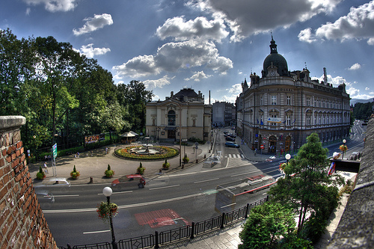

Practical information
Refunding of costs
The gross unit support is 575 euro for one foreign participant per organisation. This amount will be refunded (minus each partner’s share of the host cost for common meals, rent of venue, etc.) independently of how many nights and days the meeting are and the level of cost of hotels and meals.
Therefore, we plan for a short meeting and low-cost meals and cultural features, so you in fact can get your meetings costs covered for one participant. You are of cause welcome to stay more days or to bring more participants, but you or your organisation must pay the extra cost.
The needed documentation for your participation is a signed attendance list as well as a copy of your travel ticket/boarding card to confirm your place of departure.
Hotels
For the hotel, Agnieszka can recommend 3 places:
- President hotel, city centre, approximately 10 minutes walking distance from the meeting place, http://www.hotelpresident.pl/en/
- Qubus hotel, city centre, approximately 7 minutes walking distance from the meeting place, https://www.qubushotel.com/en/hotels/bielsko-biala/3/
- Aparthotel Ventus Rosa, a little bit more walking (15-20 minutes), but located in the Old Town, http://ventusrosa.pl/bielsko/ventus-rosa-apartments/
It is up to each partner, if they wish to book one of these hotels, or wish to find another of own choice at www.hotel.com or the like.
Information about partners’ travel schedules and hotel
Ingrid and Hans, LKCA stay at Aparthotel Ventus Rosa. They arrive Saturday in Krakow and have a flight Tuesday is 17.55 hrs from Krakow), so they must leave the meeting at 2 pm latest.
Jan Pirnat, JSKD will stay at ??. He fly to Krakow on Sunday in the evening, and fly back Wednesday morning also from Krakow.
Aron and Noé Bex, Educult will stay at President Hotel. They will arrival Sunday evening and depart Tuesday at 5pm afternoon by train.
Damien, VAN will stay at President Hotel. He flies to Katowice airport on Sunday evening and from here a train to Bielsko-Biala. Return flight from Katowice at 18:35, so he will leave the meeting about 14:00 to get the train in time.
Aira, LACM will stay at President Hotel. She will fly Sunday afternoon to Warsaw and then a train depending on time table. The same way back on Tuesday to Warsaw by train depending on the end of meeting & train time table.
Bente, KSD and Hans, Interfolk will stay at Qubus Hotel Bielsko-Biala. They will arrive Sunday evening to Krakow Airport and rent a car in the airport, and they leave Bielsko-Biala late afternoon Tuesday.
Meals
Sunday: 8 April: After arrival Sunday, you can have a dinner anywhere at the many cosy restaurants in the city centre or near your hotel.
Monday: 9 April: Breakfast at the hotel. FAIE arranges coffee breaks at the venue and lunch and dinner in the city centre.
Tuesday: 10 April: Breakfast at the hotel. FAIE arranges coffee breaks at the venue and lunch in the city centre.
Culture programme/Cultural visits
The meeting is short and we have many issues to discuss, however there should be time for a short cultural tour in Bielsko-Biala.

Map of Bielsko Biala centre

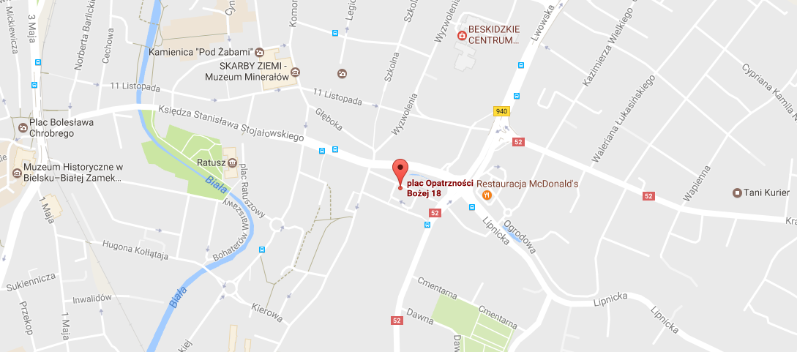
Tourist info:
Rafal and Agnieszka have send some recommendations for some interesting places to see, if somebody would have more time in Bielsko-Biała. Everything around the city center:
- Museum of Textile Industry (Old factory): https://muzeum.bielsko.pl/en/ekspozycje-stale-stara-fabryka
Location: https://goo.gl/maps/eS86EKdut3x
- Bielska Gallery BWA (The Gallery presents modern art – painting, photography, performance, installation art) - http://www.galeriabielska.pl/?sek=english_version&d=none
Location: https://goo.gl/maps/7tjTzXZWykD2
- Sulkowski Dukes’ Castle - https://muzeum.bielsko.pl/en/historia-muzeum-zamek
Location: https://goo.gl/maps/2pQPZRKraZr

Mobile numbers of the participants
Rafał Dadak, FAIE (PL) (+48) 881 676 468
Jerzy Kraus, FAIE (PL) (+48) 515 249 819
Bente von Schindel, KSD (DK) (+45) 29 64 70 40 Qubus Hotel
Hans Jørgen Vodsgaard, Interfolk (DK) (+45) 51 300 320 Qubus Hotel
Damien McGlynn, VAN (UK) (+44) 781 802 8128 President hotel
Aron Weigl, Educult (AT) (+43) 660 842 1413 President hotel
Noé Bex, Educult (AT) President hotel
Aira Andriksone, LACM (LT) (+371) 26 52 41 93 President hotel
Jan Pirnat, JSKD (SI) (+386) 31 381 238 ??
Hans Noijens, LKCA (NL) (+31) 62 14 06 197 Aparthotel Ventus Rosa
Ingrid Smit, LKCA (NL) (+31) 61 13 52 495 Aparthotel Ventus Rosa

Aims and key activities of the first meeting
The overall aim of this second meeting is to summarize the state of the project and lead the way forward for the project and for the partners. The objectives are:
- To bridge the results of the survey (WP 04/IO-2) to the succeeding compilation of good practise in thematic fields of bridging (WP 06 /IO-3),
- To prepare the provision of Curricula Guidelines (WP 07/IO-4)
- To prepare the design and test of the national pilot courses (WP 08/IO-5).

Agenda of the meeting (version 2 – 6.4.2018)
Monday, 9 April, 10 - 17.00
1. Formalities
a) Welcome and practical information
b) Appoint a moderator and a reporter
c) Approval of the agenda
d) Sign Attendance List, first day
2. Since last time: Info on matters not included in the items below
a) Presentation of new Latvian partner
b) News from the coordinator and partners
c) Other issues
3. Status of Intellectual Output 1: The Portal
a) Status of work
- Review of the design and structure of the Portal, by Hans, LKCA
- Section about culture policy trends, by Educult and Interfolk
- Section about sharing good practise, by VA, KSD and JSKD
- Section about funding possibilities for international work, by FAIE; and Interfolk
- Section about innovative observatory and dialogue forum, by JSKD, FAIE and LACM
- Section about European training events, by Interfolk and LACM
- Section about news service, by LKCA
- General presentation of the project partners and the aim, activities, and results by LKCA
- Other issues
b) Plan time schedule:
- ASAP - Who does what to catch up the loose ends
- Who does what the next half year
4. Status of Intellectual Output 2: The State of Arts survey
a) The local surveys – what can we learn on how to plan and complete it.
Evaluative round by the involved partners
b) Present and discus the Survey Summary report. Presentation by Aron, Educult
c) Clarify recommendations for the subsequent O3: Thematic Compendia
d) Plan time schedule, April – May 2018:
- Prepare English master edition
- Provide seven translated versions
5. Plan Intellectual Output 3: Five Thematic Compendia, seven language ed., Mar – Sept 2018
a) Outline the methodology for five thematic Compendia, by Damien, VA
b) Discuss and clarify the outputs and division of work
c) Plan time schedule Mar – Sept 2018: Who does what and when?
6. Plan Intellectual Output 4: Provide Curriculum Guidelines, March – May 2018
a) Outline the methodology for the Curricula Guidelines, by Hans, Interfolk
b) Discuss and clarify the outputs and division of work
c) Plan time schedule Mar – May 2018: Who does what and when?

7. Budget adjustment
a) Proposal for budget adjustment, by Hans
Tuesday, 10 April, 09 – 13
RE 1d2) Sign attendance list, second day
8. Plan Intellectual Output 5 (and T1-T7): Design and test 7 national pilot courses, June – Oct 2018
a) Outline the methodology for the pilot courses, by Jan, JSKD
b) Discuss and clarify the outputs and division of work
c) Outline the evaluation methodology (also the impact evaluation), by Hans, IF and Aron, EC
c) Plan time schedule June – Oct 2018: Who does what and when?
9. Status of the transversal dissemination activities
a) The overall status, by Damien, VAN
b) The local status, by all partners
c) The reported dissemination activities, ultimo march 2018, using the dissemination template
d) Plan time schedule: Who does what and when?
- ASAP - Who does what to catch up the loose ends
- Who does what the next half year
10. Status of the transversal progress and impact evaluation
a) Status of the progress evaluation, by Aron, Educult
b) Outline the planned impact evaluation, by Aron, Educult
c) Plan time schedule next half year: Who does what and when?
11. Status of the project management
a) Status of the coordination and internal communication – proposals for improvements.
Intro by Hans; IF and evaluative round by the partners
b) Status of the financial management, including next payments.
Intro by Hans; IF and evaluative round by the partners
c) Status of project reporting in the EU tools
- the Mobility+ Tool, Project Results Platform, Epale
d) Plan time schedule next half year: Who does what and when? financial reporting
12. Plan the next partner meeting(s)
a) WP 10: The third partner meeting in Latvia, Nov 2018, proposal by LACM
b) Need for Skype partner meetings during this spring and autumn before the third partner meeting in November. How many and when?
c) Other issues?
13. Evaluation of the previous work
a) Oral evaluation round of the project work until now
b) Oral evaluation round of this second partner meeting
14. A.O.B. (any other business)

Annexes to the agenda
NB: All the mentioned annexes can be downloaded at the virtual project archive at
the Google site - https://sites.google.com/site/bridgingsocialcapital/home

1: Formalities
c) BRIDGING - WP 05, second meeting, agenda, v1 – see archive here
d) BRIDGING - WP 02, meeting attendance List, v1 - see archive here
2. Since last time
b) Amendment request for LACM - see archive here
3. Status of Intellectual Output 1: The Portal
The preliminary plans – see the Project Bible, page 90 - 92
a) Status of work – see archive here
4. Status of Intellectual Output 2: State of Arts survey
The preliminary plans – see the Project Bible, page 93 – 97
a) Status of work – see archive with subfolders here
5. Plan Intellectual Output 3: Five Thematic Compendia
The preliminary plans – see the Project Bible, page 100 - 103
6. Plan Intellectual Output 4: Provide Curriculum Guidelines
The preliminary plans – see the Project Bible, page 104 – 106
7. Budget adjustment
See the budget revision proposal here
8. Plan Intellectual Output 5 (and T1-T7): Design and test 7 national pilot courses
The preliminary plans – see the Project Bible, page 107 - 111
9. Status of the transversal dissemination activities
The preliminary plans – see the Project Bible, page 150 – 151
The elaborated detail plan by Damien, VAN - see achieve here
c) The reported dissemination template – see archive here
The filled-in templates by partners – see archive here
10. Status of the transversal progress and impact evaluation
The preliminary plans – see the Project Bible, page 154 – 155, and page 67 – 68.
The elaborated detail plan by Angela, Educult - see achieve here
a) Filled-in progress evaluation templates, 1st step – see archive here
Filled-in progress evaluation templates, 2nd step – see archive here
11. Status of the project management
The preliminary plans – see the Project Bible, page 56 - 69, and page 156 – 157
The archive here - about Partner Agreement, Rules of Procedure and Financial Guidelines
b) Financial reporting templates for
- WP3 / IO1: The Portal, first half year – see archive here
- WP4 / IO2: Survey – see archive here
- WP 05 / P2: Second partner meeting – see archive here

