AD & HJV,

7.3.2022

***Programme and agenda,***

***version 2***

**5th partner meeting in Copenhagen, 23 – 24 March 2022**

*Content*

Time and place 1

Practical information 2

Mobile numbers of the participants 3

Aims and key activities of the first meeting 3

Agenda of the meeting (version 2 – 09.10.2017) 4

Annexes to the agenda 6

## Time and place

**Time: Wednesday, 23rd March, 9:00 – 12:00 (13:15 – 14:00 visit) &**

**Thursday, 24th March, 9:00 - 12:00**

Arrival Tuesday, 22nd March with 2 hotel nights and possible departure, Thursday afternoon.

**Place: At Vartov, Farvergade 27 D, 2nd floor, DK-1463 Copenhagen K**

NB: just 100 meter from the City Hall at the center of the city

See <http://www.vartov.dk> / [www.grundtvig.dk](http://www.grundtvig.dk) / <http://map.krak.dk/?index=yp&id=68124495&query>=

Zoom access: 1st day, Wednesday: 9 – 12: <https://us02web.zoom.us/j/88497678069?pwd=bkhnR3ZQTm1FZERZK0hsZGRmNkx6Zz09>

Zoom access: 2nd day, Thursday: 9 – 12:

<https://us02web.zoom.us/j/87282404695?pwd=S2ZLQUhZWEVmcEVGWE5VWG5KczNTZz09>

|  |  |  |
| --- | --- | --- |
|  |  |  |
| Vartov | Statue of Grundtvig | City Hall tower seen from Vartov’s courtyard |

Vartov is an historic and beautiful building with Copenhagen City Hall as its closest neighbour.

Vartov is known to have had the famous Danish poet, priest and adult educator N.F.S. Grundtvig as pastor in 33 years from 1839 to 1872 at the Vartov church which is part of the building complex.

In 1947 the Danish Grundtvig Society took over Vartov. The building underwent an extensive restoration and was particularly adapted for their new purpose, which was a continuation of the Grundtvigian youth and educational work.

Today the Grundtvig library and the Grundtvig Academy as well as many educational and cultural umbrella associations have addresses here.

## Practical information

### The meeting venue

You need to find entrance D, and here I will be to meet you and open the door and take the stairs up to 2nd floor. If needed you can also call my mobile phone, and I will come and open the door.

Hans: +45 51 300 320

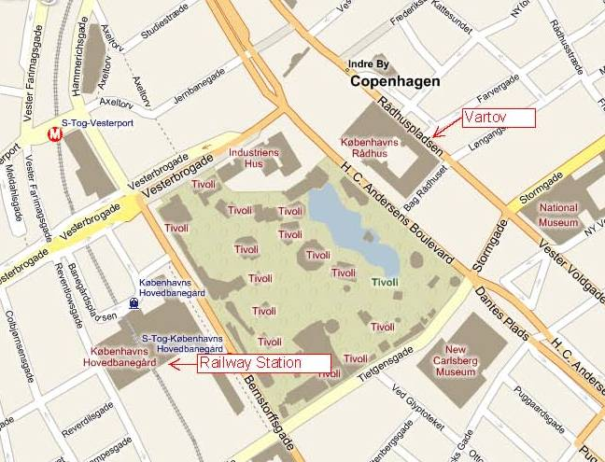 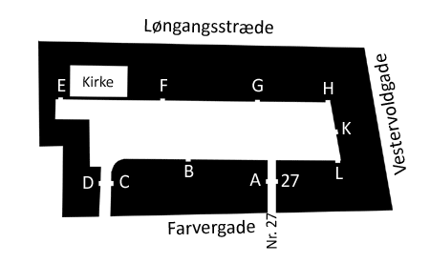

**Entrance D**

### Hotel

For accommodation, we recommend City Hotel Nebo (<http://city-hotel-nebo.8hotels.info> ).

The hotel is only 2 minutes’ walk from the Main Railway Station, and 8 min walk from the City Hall and Vartov. But you may find better options at [www.hotel.com](http://www.hotel.com) or [www.booking.com](http://www.booking.com)

### Travel information

You can get to the Main Railway Station (København H) by taking the S-train or even better by taking the metro, both from Copenhagen Airport (Terminal 3). The metro departs every 4 – 6minutes and it takes approx. 15 min. to get to the City Hall Square or the Main Railway Station. The walk from the Station to City Hotel Nebo is only 2 min.

[More info about the metro here!](https://intl.m.dk/travel-information/tickets-and-zones/) [See the metro map here!](https://intl.m.dk/media/2737/zonekort_2019_zone1.png)

Tickets for the metro are available at the DSB ticket sales counter in Terminal 3 or at ticket machines. Please note that the ticket machines do not accept notes, only coins and cards such as VISA, etc.

**Your luggage the second day after check-out at the hotel**

If you wish, you can bring your luggage to Vartov the last day after check-out from the hotel, and you can keep it here and get it after the meetings ends in the afternoon.

### Meals

Breakfast: AT the hotel

Coffee breaks: Wednesday morning and afternoon and Thursday morning will be served at the

meeting room

Lunch: Wednesday and Thursday from 12 – 13 at cafes nearby. Fx:

Puk, <https://www.restaurantpuk.dk/> Vandkunsten 8, 1467 kbh k

Restaurant Nytorv, <https://nytorv.dk> , Nytorv 15, 1450 København K, 33 11 77 06

Katz, <https://katz.dk> Frederiksholms Kanal 1, 1220 København

Dinner: Wednesday at 19:15 in [RizRaz, Store Kannikestræde 19, 1169 København](https://www.rizraz.dk/), 33150575

We can meet outside Vartov at 18:15 and walk in the old city to the restaurant.

After the dinner, we can walk to [Nyhavn to have a drink.](https://www.visitcopenhagen.com/copenhagen/planning/nyhavn-gdk474735)

### Tourist information

Tourist guide to visit Copenhagen – see <https://www.visitcopenhagen.com/>

See also <https://www.copenhagen.com/attractions> or [Tripadvicer](https://www.tripadvisor.com/Attractions-g189541-Activities-Copenhagen_Zealand.html)

## Participants – onsite & online / mobile numbers

Agnieszka Dadak, FAIE (PL) onsite (+48) 511 551 439

Rafał Dadak, FAIE (PL) onsite (+48) 881 676 468

Jerzy Kraus, FAIE (PL) onsite (+48) 515 249 819

Aron Weigl, EDUCULT (AT) onsite (+43) 660 842 14 13

Oliver Löscher, EDUCULT (AT) onsite (+43) ??

Camille Lechoux, FWC/CNTI (CY) [1] onsite (+357) ??

Hans J. Vodsgaard, Interfolk (DK) onsite (+45) 51 300 320

--

Ana Carneiro, RightChallenge (PT) online

Sandra Marisa, RightChallenge (PT) online

Lorenza Lupini, COOSS (IT) online (+39) 328 761 02 27  
Luca Bordoni, COOSS (IT) online (+39) 338 6510148

## **Topics of the meeting**

The objectives of the meeting are to clarify:

* The competence descriptions including job roles and levels (homework)
* The examination system for the certification, including micro certification
* How the examination (and certification) can take place
* How the training units can be transformed to training modules and exam questions
* How to secure examination system for continued certification
* The status of our dissemination and plans for concluding dissemination

## Agenda of the meeting

|  |  |  |
| --- | --- | --- |
| **Wednesday, 23rd of March, 9:30 – 16.00** | | |
| 1.  9:00 – 09:15 | Welcome  Appoint moderator and reporter (Proposed: Agnieszka and Hans)  Approve the agenda, 1st day  Signing the attendance list, 1st day | |
| 2.  09:15 – 10:00 | Discuss and decide the competence descriptions including job roles and levels, which are used for certification (homework for the meeting) | |
| 3.  10:00 – 10:30 | Discuss and clarify how the certification units can be transformed to training modules  Short outline by Interfolk |
| **10:30 – 10:45** | **Coffee break** | |
| 4.  10:45 – 11:30 | Present and discuss the possible examination systems for the certification, including micro certification.  Review of the examination systems chosen as benchmarks at TPM2,  By FAIE | |
| 5.  11:30 – 11:55 | Decide guidelines for the examination systems for the certification, including the micro certification. | |
| **12:00 – 13:00** | **Lunch** at [Restaurant Nytorv,](https://nytorv.dk) Nytorv 15, 1450 København K, +45 33 11 77 06 | |
| 6.  13:15 – 14:00 | Group visit to [FFD – The Association of Folk High School in Denmark,](https://ffd.dk/)  Nytorv 7, 1450 København K  Topic: To hear about FFD’s experiences with recognition of prior learning | |
| 7.  14:15 – 15:30 | Onsite excursion in the old city | |
| 15:30 – 18:30 | Free time | |
| 18:30  19:00 - 20.30 | We meet outside Vartov, and have a 30 min walk and talk in old city centre to the restaurant.  Dinner at [RizRaz, Store Kannikestræde 19, 1169 København](https://www.rizraz.dk/), +45 33 15 05 75  After dinner, we can if wanted, walk to [Nyhavn to get a coffee, bear or drink.](https://www.visitcopenhagen.com/copenhagen/planning/nyhavn-gdk474735) | |

|  |  |
| --- | --- |
| **Thursday, 24th of March, 9:30 - 12.30 (13:45)** | |
| 8.  09:00 – 09:10 | Welcome  Appoint moderator and reporter (Proposed: Agnieszka and Hans)  Approve the agenda, 2nd day  Signing the attendance list, 2nd day |
| 9.  09:10 – 09:55 | Present, discuss and clarify how the examination (and certification) can take place?  Short outline by FAIE |
| **09:55 – 10:05** | **Short break** |
| 10.  10:05 – 10:45 | Present, discuss and clarify how the examination for continued certification can take place?  Outline by Rightchallenge. |
| **10:45 – 11:00** | **Short coffee break** |
| 11.  11:00 – 11:25 | The status of our dissemination and plans for concluding dissemination  Summary by Rightchallenge |
| 12.  11:25 – 11:45 | Plan the final event, the Structured Democratic Colaboratory (in a form of LTT) planned in Nicosia, Cyprus, May 16th - 20th.  Short outline by CNTI |
| 13.  11:45 – 12:00 | Preparation for the next and final steps in the project, evaluation, final matters, and farewell. |
| 12:30 – 13:30 | An extra option / Lunch at [Katz, Frederiksholms Kanal 1, 1220 København](https://katz.dk) |

1. Future Worlds Center - Cyprus Neuroscience & Technology Institute